**Saint Lucia**



**Red Cross Society**

**Community Risk Reduction**



**Healthier, Safer Communities**

BEXON

**VULNERABILITY AND CAPACITY ASSESSMENT**

***April 2011***

# Acknowledgements

The St. Lucia Red Cross along with the team of dedicated members from the community of Bexon would like to express their deepest gratitude to the many persons and institutions who made this document a reality.

To the Red Cross volunteers, NIT members who participated in undertaking the baseline surveys which paved the way forward for this document and the future of the community, thanks for the support. Without a venue the nightly session would have been difficult to conduct and for that we thank the Principal of the Bexon Primary School for the use of the School to conduct the sensitization meetings along with the VCA and CDRT training sessions.

The support given by the government statistic department in making available the secondary data on the community was critical in analysis the outcome of the VCA and we would surely like to thank you for the information and your kind assistance.

To the community members of Bexon who took time to answer the baseline survey questions and those who cooperated in welcoming the Red Cross members and other community members into their homes and business places to complete the family emergency plans, your efforts and energies is a reflection of the willingness of Bexon to be a more resilient community.

.

# Table of Contents

**Abstract …………………………………………………………………………………………..4**

**Foreword …………………………………………………………………………………………5**

**Introduction ……………………………………………………………………………………...6**

**Part 1 : Vulnerability and Capacity Assessment of Bexon ……………………………………7**

What is a VCA ? …………………………………………………………………………..7

How is the VCA carried out ? ……………………………………………………………..8

1. Gathering data from secondary sources …………………………………………………...9
2. Direct observation …………………………………………………………………….10-12
3. Focus group discussion ……………………………………………………………….13-20

**Part 2 : Risk Assessment in Bexon …………………………………………………………….21**

Methodology for a Risk assessment ……………………………………………………………..21

1. Identifying hazards and their potential impact on the community …………………...24-25
2. Local capacity to respond to hazards………………………………………………….26-28
3. Types of measures to mitigate hazards ……………………………………………….29-31
4. Ability to act on hazards (CIA/T analysis) …………………………………………..32-34
5. Plan of Action ……………………………………………………………………………35

Conclusion: The next steps……………………………………………………………………..36

# Annex 1: List of participants in the Vulnerability and Capacity Assessment……………....37

# Abstract

Four months have passed since the commencement of this journey to furnish the community of Bexon with a VCA and a fully operational CDRT. The motivation to approach the Saint Lucia Red Cross to have the Readiness to Respond project implemented in Bexon came after the devastating impact of Hurricane Tomas on October 30th 2010.

The saint Lucia red cross had already targeted bexon as one of the communities for the Readiness to Respond programme. None the less with the passage of hurricane tomas some of the residence approached the Red Cross for help and education in disaster matters.

These were community members who were very much involved in relief efforts of Hurricane Tomas and were very concern over the possible impact of another disaster on their community. The group grew finally evolved a team comprising 17 CDRT members.

As a platform to launch the VCA data collection session a Community Based First Aid session was conducted with participants and focused on basic techniques dealing with Check-Call-Care, stopping bleeding in wounds, treating burns, adult and infant CPR including how to assist a choking victim. The sessions proved worthwhile as it provided participants with much needed skills.

Participants were introduced very early to the mapping exercise along with a historical pictorgram so as to gain appreciation of the community and to foster a team spirit. The exploration of the community to draw the spatial map and source information on the history of Bexon proved to be an educational experience for the participants. Though it was difficult to get historical information, a historical pictogram was developed.

Exploring the social and institutional networks of the community was an activity which brought some reflection on the closeness of the community especially among the various community groups while also revealing the socialization patterns of various groups such as the young, women and older men.

The make-up of the VCA data collection team predominantly comprised of older persons especially women, various church and community organization representatives and a few men. This allowed for a wide and varied view on the data in accessing the information to put in the VCA.

# Foreword

The present VCA study was carried out through a series of community meetings commencing in January of 2010 and concluding in June 2011 with the Bexon community.

This study is part of the International Federation of Red Cross and Red Crescent Societies (IFRC) regional project “Improving the preparedness of Caribbean communities to respond to disasters affecting their locality”. This program, implemented in 2009-20011,also covers the National Societies of Trinidad & Tobago, Surinam, Bahamas, Antigua, St. Kitts, Barbados, St.Vincent and Guyana, through the support of the European Commission Office for Humanitarian Aid (ECHO) and the United States Office for Disaster Assistance (OFDA).

# Acronyms

CIA Change / Influence / Accept

CIT Change / Influence / Transform

ECHO European Commission Office for Humanitarian Aid

IFRC International Federation of Red Cross and Red Crescent Societies

OFDA United States Office for Disaster Assistance

VCA Vulnerability and Capacity Assessment

NEMO National Emergency and Management Organisation

SLURC St. Lucia Red Cross

CDRT Community Disaster Response Team

NIT National Intervention Team

# Introduction

In January 2011, the rural Castries South-East community of Bexon embarked on a journey of self-analysis, examining its strengths and weaknesses, the external and internal threats and the resources it has to cope with these threats. Heads of households, local leaders of religious and sports groups, workers of all trades especially the women of the community and other concerned members, discussed the history of their community and the problems they encounter. They shared their experiences and their tips for overcoming daily difficulties. As a group, they identified the main problems ahead and discussed the future of their common home.

The VCA data for this community happened during relief and recovery operations and provided a great opportunity to capture the real-time impact of such a disaster on the community and possible future impact. This added to the motivation of the community reflected in their willingness to volunteer with the relief operation of the Saint Lucia Red Cross and a willingness from residence to provide information.

The community very early in the project understood its relevance due to past experiences with Hurricane Allen (1980) and more recently Tropical Storm Debbie (1994) and Hurricane Tomas (2010). With a population of 2,440 and a 2.8 average household size1, the community can be described as a farming community but with the passage of time has moved to being made up of construction, private sector and government workers.

The process was organized by volunteers and staff of the St. Lucia Red Cross Society (SLURC), along with other community members as part of a region-wide attempt to improve community-based disaster preparedness. The community work was based on the methodology known as “Vulnerability and Capacity Assessment”, or VCA. The purpose of this assessment is to identify and understand the most pressing issues and threats in the community (vulnerabilities) while simultaneously identifying the local and external resources available to minimize the risks to the villagers (capacity).

The VCA approach is composed of a series of tools for community-based participatory consultations to ensure a better understanding of how the community functions. Behind this process lies the assumption that a community is more aware of its own limitations and can therefore organize itself better to overcome them. In the context of the SLURC project, the stated objective was to improve the capacity of the community to cope with the disaster-related risks in its environment.

To this end, the first section summarizes the results from the VCA process, as carried out in Bexon. It presents the history, the local dynamics and the coming challenges, as perceived by the people who live in Name of Village. Although this program explicitly focuses on natural disasters and hazard mitigation strategies, the results presented in this first section provide guidelines for a broader approach towards sustainable community development.

The second section focuses on the output from the community focus groups in relation to the risks faced by the community: Which are the main risks? Can they be mitigated? By whom? Using the results presented in the proposed Action Plan, the community members – supported by SLURC teams – will identify and implement strategies to mitigate these risks. The information gathered here will also provide the necessary baseline information for monitoring and evaluation the progress of the community.

1 Quoted from the *St. Lucia 2010 Housing and Population Census Report pg.24*

Part 1: Vulnerability and Capacity Assessment of Bexon

### What is VCA?

Vulnerability and Capacity Assessment (VCA) is a participatory investigative process designed to assess the risks that people face in their locality, their vulnerability to those risks, and the capacities they possess to cope with a hazard and recover from it when it strikes. Through VCA, National Societies can work with vulnerable communities to identify the risks and take steps to reduce them by drawing on their own skills, knowledge and initiative. **In sum, VCA helps people to prepare for hazards, to prevent them from turning into disasters and to mitigate their effects**.[1]

***Vulnerability*** *can be defined as:*

*The characteristics of a person or group in terms of their capacity to anticipate, cope with, resist and recover from the impact of natural or man-made hazards****.***

The definition of vulnerability suggests that it cannot be described without reference to a specific hazard or shock. So, the question that must always be asked is, ''Vulnerability to what?" People living along coastal areas or rivers may be vulnerable to seasonal storms and flooding, while the inhabitants of countries with social, political and economic problems may face difficulties in achieving a satisfactory and sustainable quality of life.

*The reverse of vulnerability is* ***capacity****, which can be described as:*

*The resources of individuals, households, communities, institutions and nations to resist the impact of a hazard.*

The coping strategies of people in response to various hazards will differ from one society to another and will often change over time. People in chronically-prone countries facing multiple hazards, such as drought, locust infestation and civil unrest, find their capacity levels weakening, reducing their ability to mitigate the effects of the next crisis.[2]

### How is the VCA carried out?

The VCA process relies on a few key principles:

**Data collection:** Preliminary data can be collected through the use of questionnaires, developed specifically for each community or for each type of hazard. However, as information is not always immediately available on the ground – because of time constraints, security issues or financial resources – the VCA process also relies on the gathering of secondary data. Precious information about the community can be gathered from research by government bodies, the United Nations and other development- and research-based organizations.

**Community participation:** The goal of the VCA process is to empower the community to allow it to respond on its own to the risks to which it is subjected – or allow it to identify those who can help it to respond. For this reason, community members constitute the core of the process. The main criterion for a successful VCA is the receptiveness of the local community and its willingness to be an active part of the process. Only if all vulnerable groups are included, can they find collective answers to the threats they face.

**Sharing information:** The VCA process helps the community understand its relation to its environment. Through discussions among neighbors and the collection of data, the community members will be better able to understand – and therefore reduce – the threats to which it is subjected. The final VCA document also offers an opportunity to share information beyond the community, by bringing up issues to the relevant authorities, partner organizations or local leaders.

The VCA is mainly used ***to identify in advance, and change where possible, the conditions that create or contribute to the state of vulnerability of at-risk populations***.[3] As such, the main usefulness of VCA comes from an improved understanding of the risks and of measures to mitigate that risk. To gather all information relevant to a better understanding of the community, the following steps have been followed:

1. Review of secondary sources: this first, crucial, step consists in collecting information that already exists, to avoid duplicating efforts already carried out. Most of this phase consists in collecting written material, or identifying all resources relating to a better understanding of the community;
2. Direct observation: A summary presentation of the community, by someone external, often allows to get a first impression of the local dynamics and main issues;
3. Focus group discussions: The heart of the VCA process lies in this phase of community interaction, using tools for the involvement of all stakeholders.

Based on these three steps (presented hereafter in points 1, 2 and 3), disaster-related information has been gathered and is presented in part 2.

## Gathering data from secondary sources

### Location of the community

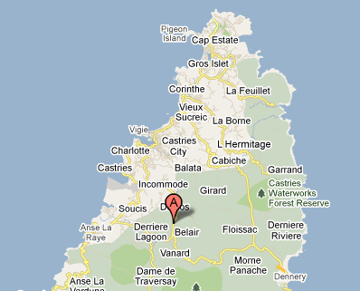

The Community of Bexon is located in the Southwestern section of the island about 10Km or just 18 minutes drive from the Capital City Castries.

Coordinates: 130 95’ 47.51” N 600 97’ 71.39” W

### 

### Population of Bexon

2,440 Persons / Household Population: 836 / Males: 1255 / Females: 1185 (2010 Census)

### Community map

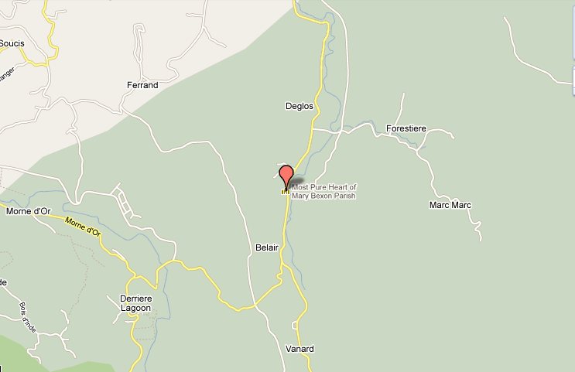

## Direct observation

The Community of Bexon is located in the Southwestern central section of the island about 10Km or just 18 minutes drive from the Capital City Castries. Though it forms part of a larger rural constituency of Castries Southeast, it is the largest and most populated area in that region.

The information presented in a table form below, highlights some of the major areas focused on during the direct observation and captured some views on the community that may have been missed using other forms of data collection:

|  |  |
| --- | --- |
| ***Demographics*** | ***Health, Sanitation & Essential Services*** |
| * The community has a population of 2440 persons with a household population of 836 and an average family size of 2.8 * Gender breakdown: Males- 1255 / Females- 1185; * More than 50% of the population falls between the ages of 0-40 reflecting the community has a high percentage young person and middle age persons * An unemployment population of 18.6% predominantly among young persons. In comparison the gap between the unemployed young men and women is 1% * While there is a high presence of extended families households are predominantly nuclear families with 2 to 3 children; * More than 60% of households are headed by men * Dwelling houses are predominantly made from wood (plywood) or concrete blocks, with wood accounting for 49% of the material most houses are made of. | * The community is serviced by a Health Center, Post Office and the Bexon Primary and Infant Schools * There is also the presence of the Catholic, Seventh Day Adventist Church and the Jehovah Witnesses Kingdom Hall, Pentecostal and Baptise Church; * Police presence can be had from the Marigot Sub Police Station which is approximately 10 minutes driving distance away or Castries Police Station with an estimated 18 minutes away. * Medical and Fire Emergency Services is accessed from the Castries Fire Station; * The convenience of the Labayee Day Care and Teacher Lira’s Pre-School; * The main national Hospital, the Victoria Hospital is about 15 minutes away from the community along with the National Wellness Center and the Tapion Private Hospital * A proper garbage collection system exists throughout the community however due to the rural and forested nature of the community, dumping of garbage takes place in backyards and the river. * Pipe borne water exist within the community and most persons access water from their homes, however the river is also utilized during water shortages and for agricultural purposes * While almost 46% of houses have septic tanks there is the absence of as sewer systems;   A high percentage of home almost 50% still use Pit latrines (VIP);   * Electricity is available throughout the community with most areas having the presence of electrical lamp except feeder roads or tracks which may not be properly lighted; * Landlines (telephone) are widely available in the community however mobile phones have become the predominant mode of communication; |
| ***Daily Activities*** | ***Visible Vulnerabilities and Capacities*** |
| * Adults are predominantly engaged in economic activities such as farming; * Women are generally involved in employment, caring of children and church related activities; * A large percentage of the young unemployed women would either be at home taking care of house chores of “liming” in the community; * Recreational activities of adults tend to stem around the playing of dominoes, attending “Country and Western” dances and watching television; * Adult males tend to socialise around the community rum shops; * Gambling and the sale of illicit drugs are associated with young unemployed men; * A large percentage of men are either employed in the farming or construction industry; * Though there are a number of Christian denominations which form part of community life however, Catholicism and Seventh Day Adventist are the dominant ones. * The Bexon Field and Court serves as the main sporting areas for the community has been totally destroyed with the passage of Hurricane Tomas; * Public Transportation plays a vital part in the daily lives of residence and is the major form of transportation used by the community; | ***Vulnerabilitie****s*   * The proximity of a number of homes to the Bexon Highway and the Bexon River which is one of the major hazard; * Dark areas in some forested sections and alleys in the community; * The presence of the river running throughout major sections of the community; * Erosion along major parts of the community and in sections affected by landslides during Hurricane Tomas; * Large areas of bush which may tend to encourage rodents and stagnant water along with the absence of drains; * The treacherous nature of the Bexon Highway which is a common site of vehicular accidents and loss of lives as a result; * The close proximity of utility poles predominantly electricity to homes, businesses and the highway; * The plethora of rum shops and illegal drug sale points in the community; * The high prevalence of squatting “ghetto” areas in certain sections of Bexon;   ***Capacities***   * Availability of small community shops * Farmland and crops; * Playing Field * River and springs * Human resources (teachers, police officers, mechanics, heavy equipment operators, farmers, construction workers, etc.) * Heavy equipment, minibuses * Health Centers, Schools and Churches * Roads and access routes along with bridges * Organised groups such as the Development Committee, Youth and Sports Council, Church Youth Groups * Presence of 2 Gas stations * Labayee Community Center * Bakeries * Day Care and Pre-School * Trees |

## Focus group discussions

***A focus group discussion is a qualitative information-gathering tool whereby a group of selected individuals, guided by a facilitator, are invited to give their thoughts and views on a specific issue***.[4] To facilitate the process of interaction with key community stakeholders, the International Federation has developed a series of tools for participatory appraisals. These include, but are not limited to:

1. Historical profile;
2. Historical visualization;
3. Seasonal calendar;
4. Institutional and social network analysis;
5. Livelihoods and coping strategies analysis;
6. Mapping;
7. Transect walk;
8. Household/neighborhood vulnerability assessment;
9. Assessing the capacity of people’s organizations;
10. Venn diagram.

Not all tools are used every time, nor are these tools the only ones used to encourage community mobilization. More than the tools, the success of the VCA is measured by the mobilization it induces within the targeted community.

The following tools were used to collect the date for the Bexon VCA:

* Historical pictogram;
* Seasonal calendar;
* Institutional and social network analysis;
* Livelihoods and coping strategies analysis;
* Mapping;
* Transect walk;
* Assessing the capacity of people’s organizations;

### Historical Pictogram

The historical pictogram revealed that in the 1920’s Bexon was predominantly a forested area with a very low population of crop production and livestock farmers. During that same period the river flow was substantialy high and flowing through its natural course.

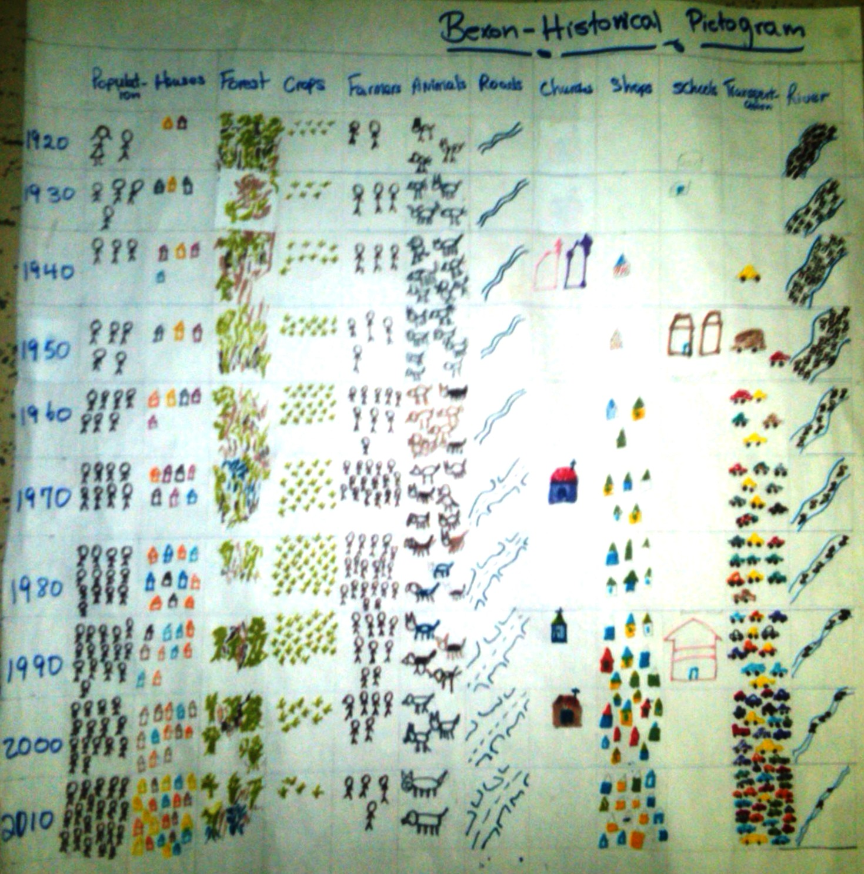

The 1970’s saw a drastic increase in population and houses, coupled with a reduction in forested lands and a subsequent increase in crop production and transportation.

The same period saw major development to the road network and a drastic reduction on the volume of water flowing from the Bexon river.

The 80’s and 90’s saw a further increase in population, vehicular traffic, road network and a drastic reduction on famers and crop production.

The reduction in the forest cover of the area coupled with the exposure of soil due to farming and development purposes also contributed to the reduction in the volume of flow from the Bexon river. Developments throughout the years also forced a redirection of the river flow. Thus previous disaster and with the recent passage of Hurricane Tomas was further proof that such developments have exposed the community to major landslide and flash flooding.

The major impact of Hurricane Tomas on the community was not just limited to flooding from the river but rather large deposits of silt which caused most of the damage to homes and property throughout the community and hindered emergency organizations from reach Bexon.

A major point in history of the community was the Ravine Poisson incidence in November of 1938 known historically as Black Monday. Abnormal rainfall during that period brought about much flooding and landslides around the island. The communities of L’Abayee and Ravine Poisson were affected by these major floods and landslides. The most catastrophic took place in Ravine Poisson on the morning of November 21st 1938. Nearly half of the mountain on the Western side of Ravine Poisson collapsed sending liquid clay down into the community and destroying property and causing deaths. On the second day another landslide occurred claiming more lives. The final death toll reached 96.

Due to the present conditions of the area and the regular occurrence of landslide community members are very much concerned that such an event will occur again and would most-likely claim more lives due to the high population of the community.

### Seasonal Calendar – Bexon (Festivities)

|  |  |  |  |  |  |  |  |  |  |  |  |  |
| --- | --- | --- | --- | --- | --- | --- | --- | --- | --- | --- | --- | --- |
|  | **J** | **F** | **M** | **A** | **M** | **J** | **J** | **A** | **S** | **O** | **N** | **D** |
| **Activity** |  |  |  |  |  |  |  |  |  |  |  |  |
| Cricket | **X** | **X** | **X** | **X** | **X** | **X** | **X** |  |  |  |  |  |
| Football | **X** | **X** | **X** | **X** | **X** | **X** | **X** |  |  |  |  |  |
| Jounen Kweyol |  |  |  |  |  |  |  |  |  | **X** |  |  |
| Mothers’ Day Activities |  |  |  |  | **X** |  |  |  |  |  |  |  |
| Fathers’ Day |  |  |  |  |  | **X** |  |  |  |  |  |  |
| Independence Day |  | **X** |  |  |  |  |  |  |  |  |  |  |
| Easter |  |  |  | **X** | **X** |  |  |  |  |  |  |  |
| Valentine’s Day |  | **X** |  |  |  |  |  |  |  |  |  |  |
| Karaoke | **X** | **X** | **X** | **X** | **X** | **X** | **X** | **X** | **X** | **X** | **X** | **X** |
| National Day |  |  |  |  |  |  |  |  |  |  |  | **X** |
| Cock Fight |  |  |  | **X** | **X** |  |  |  |  |  |  | **X** |
| Christmas Celebrations |  |  |  |  |  |  |  |  |  |  |  | **X** |
|  |  |  |  |  |  |  |  |  |  |  |  |  |

### Seasonal Calendar (Hazards)

|  |  |  |  |  |  |  |  |  |  |  |  |  |
| --- | --- | --- | --- | --- | --- | --- | --- | --- | --- | --- | --- | --- |
|  | **J** | **F** | **M** | **A** | **M** | **J** | **J** | **A** | **S** | **O** | **N** | **D** |
| **Activity** |  |  |  |  |  |  |  |  |  |  |  |  |
| Hurricanes |  |  |  |  |  | **x** | **x** | **x** | **x** | **X** | **X** |  |
| Floods | **X** | **X** |  |  |  |  | **x** | **x** | **x** | **X** | **X** | **X** |
| Electrical fires | **X** | **X** | **X** | **X** | **X** | **X** | **X** | **X** | **X** | **X** | **X** | **X** |
| Road accidents | **X** | **X** | **X** | **X** | **X** | **X** | **X** | **X** | **X** | **X** | **X** | **X** |
| Friday Night Fetes | **X** | **X** | **X** | **X** | **X** | **X** | **X** | **X** | **X** | **X** | **X** | **X** |
| Gambling | **X** | **X** | **X** | **X** | **X** | **X** | **X** | **X** | **X** | **X** | **X** | **X** |
| Cock Fighting | **X** | **X** | **X** | **X** | **X** | **X** | **X** | **X** | **X** | **X** | **X** | **X** |
| Illicit Drug sales | **X** | **X** | **X** | **X** | **X** | **X** | **X** | **X** | **X** | **X** | **X** | **X** |
|  |  |  |  |  |  |  |  |  |  |  |  |  |

### Institutional and social network analysis

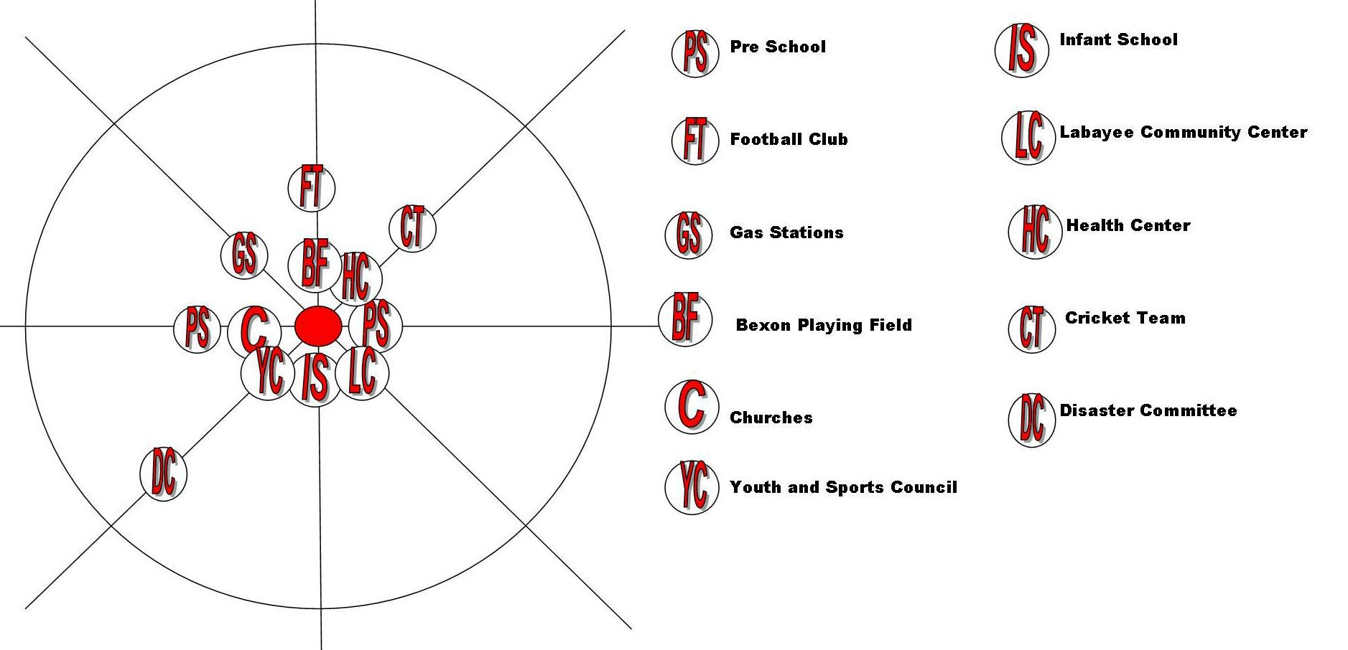

The Bexon Primary and Infant School play a vital role in the educational development of young persons and they are seen as critical institutions in the community not just because of their function but also their relevance as a hurricane shelter and a meeting point of a number of community activities.

Religious life in the community and even response to assisting the community is centered predominantly on the Catholics and Seventh Day Adventist Churches and they play a critical role in the development of Bexon.

Apart from the various Church organizations with their associated youth structures the South Castries Youth and Sports Council based in the community is the focal point for youth activities in the community. Activities tend to be of a sporting nature, such as football and cricket and generate much excitement during seasonal tournaments.

Though a farming community, a number of avenues and social amenities exist and facilitate the recreational activities of community members:

* Attendance at Church and various church activities predominantly by adults and a sector of youth;
* Activities hosted by the Youth and Sports Council, which are predominantly, Football and Cricket Competitions. The hosting of these activities has been affected by the destruction of the Court and Bexon playing field with the passage of Hurricane Tomas;
* School activities and gathering around the school compound after school hours by young persons;
* Gathering around the various rum-shops/bars especially by minibus drivers and young men;
* Gambling predominantly by the younger men;
* Young women tend to engage in attending parties, Karaoke and “liming” at various gathering points within the community;

### Livelihoods and coping strategies analysis

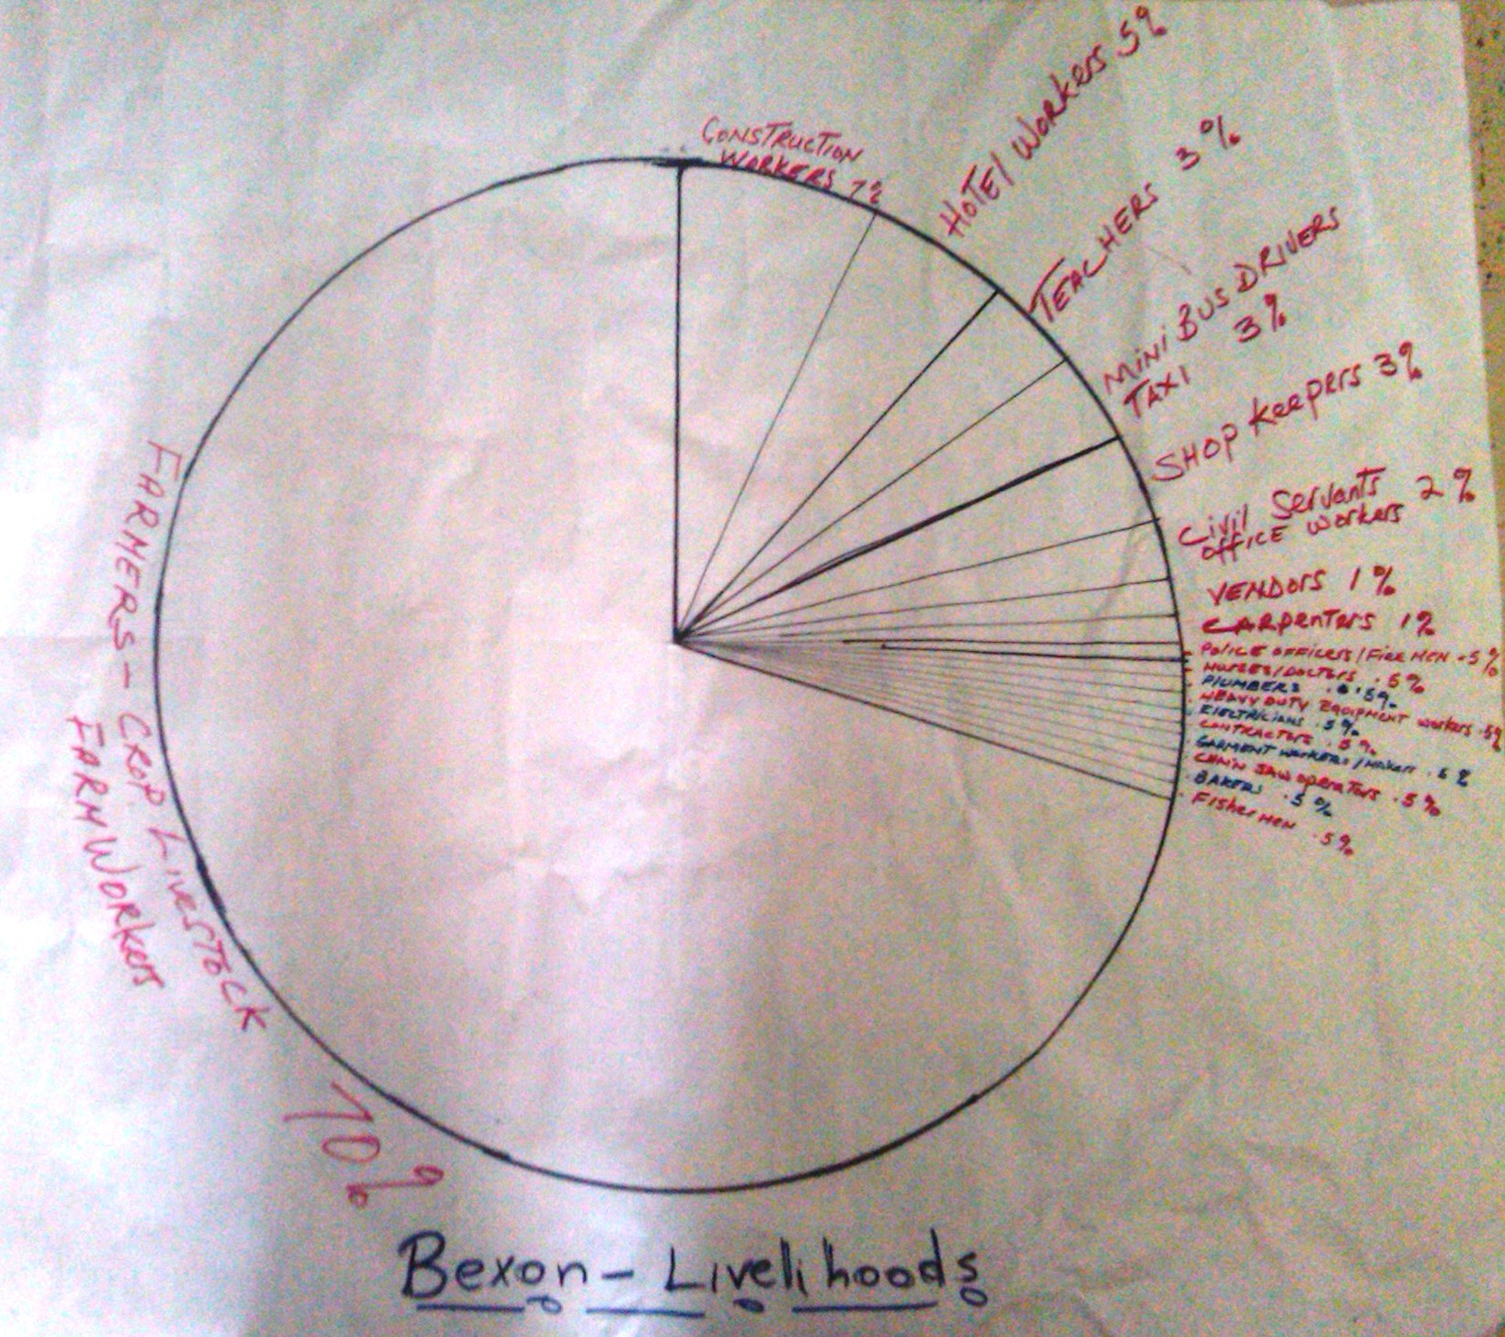

Crop and livestock production are the main forms of livelihood in this community, including hiring of persons as farm workers. This sector provides employment for 70% of the population.

The construction industry is the next highest employment sector with 7%

Civil servant employees make up just about 5% of the population with the other major areas being bus drivers and shopkeepers.

The Hotel sector is rapidly becoming a high source of employment particularly for young persons especially women and contributes 5% to the livelihood population of Bexon.

Though the community looks is considered rural the presence of a number of social amenities and its proximity to the City of Castries has allowed it to assume a suburban atmosphere.

During difficult times as was apparent during the 2010 recession and the impact of Hurricane Tomas nationally and on the community, persons tend to get support from the following:

* Family
* Church
* Constituency Representatives (Political party representatives)
* Neighbors
* Friends

It’s noted that during such difficult times a number of day-to-day activities may be affected .To ensure some level of survival or a coping strategy. The following actions are taken:

* Shopping for clothing and non-basic food items is reduced.
* Travelling to the city for leisure is reduced.
* The level of partying and saving up for activities such as carnival and other festive events is cut back but mostly among the older persons-this may not be the same in the case of the youth
* Children are sent to school less or a rotation of children in a household with a large number. However parents are encouraged to send the students to school because of the presence of the school feeding programme at the Bexon Government School.

### Transect walk

|  |  |
| --- | --- |
| Section1: Odsan Gap to Changoo | Section 2: Changoo to the Bexon Health Center |
| * Business places and homes close to the road including a vehicular repair shop; * Community members are exposed to the use of chemicals and spray paints from the garage; * This is easily flooded due to the close proximity to the Bexon river; * Cement dust from a warehouse that sells cements; * Chemicals from Paints Plus; * Area is threatened due to possibility of landslides along the road; * The presence of a gas station exposes the area to a level of risk from fire/explosions | * Area is exposed to a level of risk from a possible fire/explosion from the Bexon gas station; * 2 garages in the area exposes community to chemicals and the risk of fires/explosions; * Poor drainage * Possible land slippage areas above the gas station; * This area is exposed to flooding from the Bexon River * The width and manner of construction of the Bexon Primary School bridge makes it unsafe; |
| * Overall this section of the community is exposed to high levels of vehicular traffic and this poses a serious threat to residence, homes, business places and to students of the various schools in the area. * The area is heavily forested with fruit trees and bush; * Large percentage of houses are expose to overhanging trees and power lines; * All houses in this section are covered with galvanized roofing materials and the wooden houses have poorly built roofs which have no straps to secure the roofs; * There seem to be no form of safety protocols around the garage and LPG sales area; | |
| **Section 3: Health Center to Barre de-Lisle** | |
| * The bridge linking the lower portion of the community and the Barre de-lisle is unsafe and is poorly well lit; * Abandoned burnt bakery next to the highway * Bread master bakery and Rambally’s garage are close to the main road * The community center is next to the garage exposing the building and persons to a level of risk to fires/explosions; * This area is also prone to flooding from the Bexon river; * Most houses in the area have very poor roof structures and very poor drainage around the homes; * The right side of the road heading out of Bexon is more exposed to the river thus prone to flooding; * The left side however is mostly elevated and exposed to landslides; * The areas is heavily forested and most homes in this section are exposed to falling trees and utility poles and wires; * The upper section of this area of the left side heading to Barre De-lisle has a high level of wooden houses that are very close to each other and access is very limited except through small tracks; | |

1. **Mapping**

Picture of Resource Map – Bexon

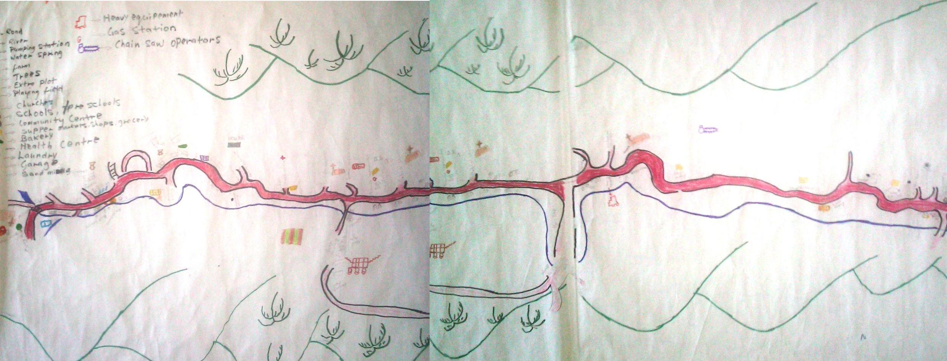

Picture of Hazrd Map - Bexon

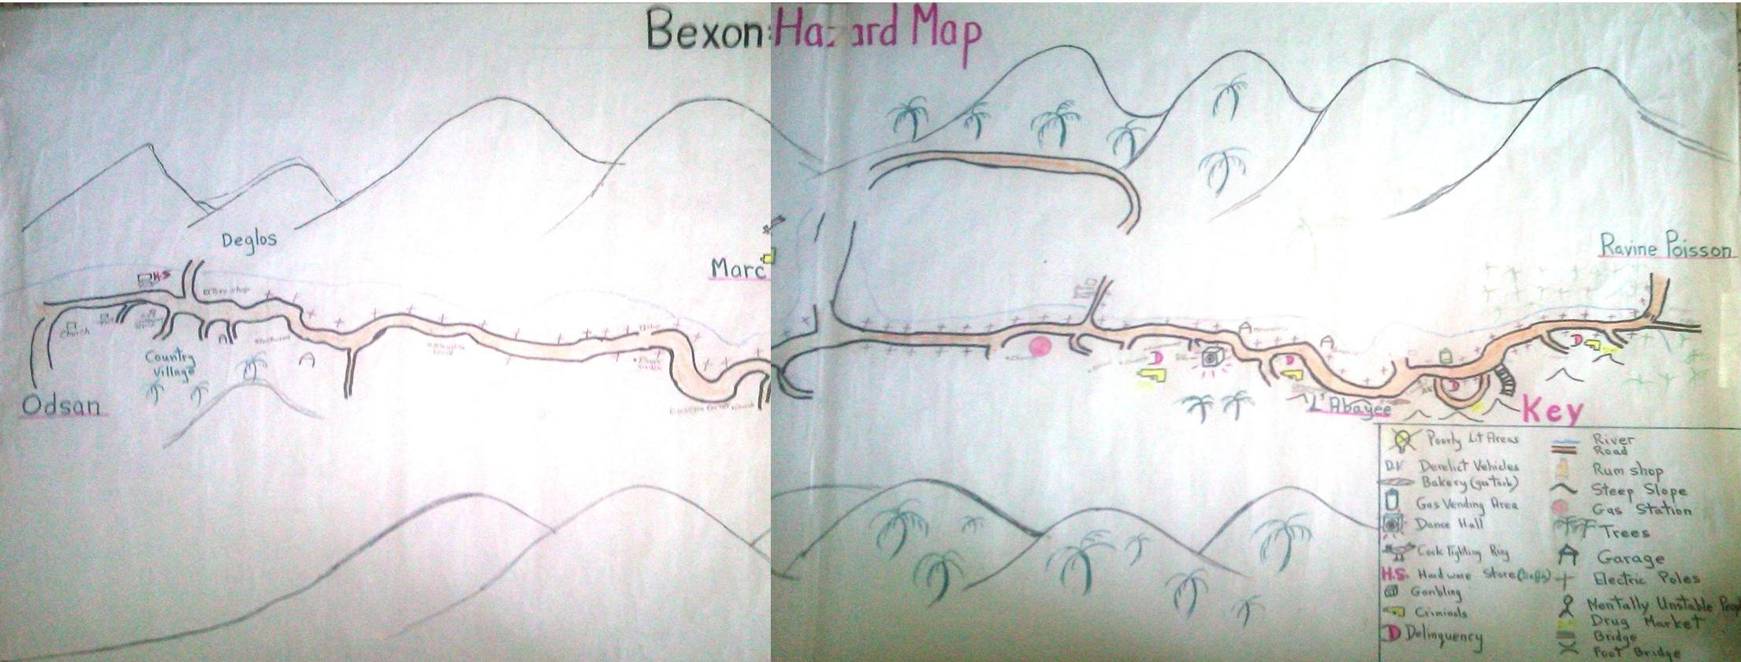

1. **Household/neighborhood vulnerability assessment**

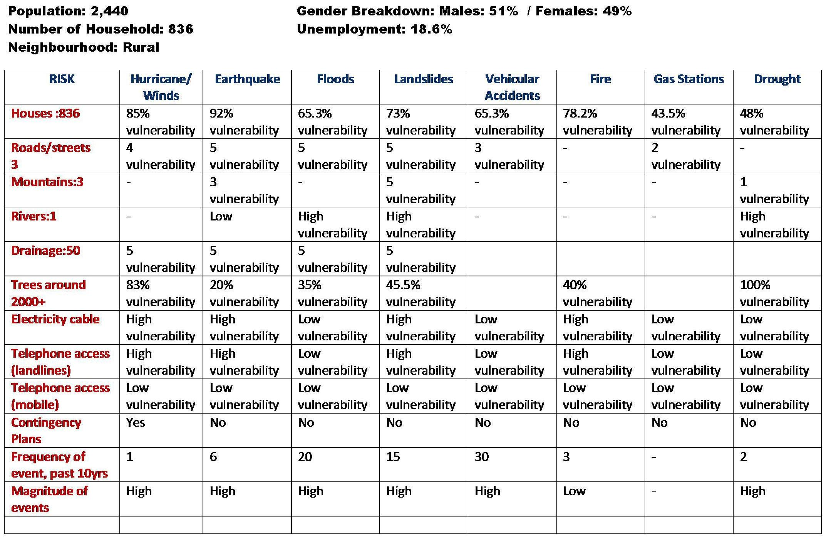

The vulnerability assessment of the community revealed that the greatest risks which homes are exposed to are as follows:

* Hurricane winds
* Floods
* Landslides
* Vehicular accidents
* Fires

These are also of the major concern to residence due to the frequency with which these events have occurred and continue to occur. The community has been scared by the first major disaster of 1938 and has continued to be affected by major flooding and landslides throughout its history. The Bexon Highway is considered one of the most dangerous roads on the island and on a yearly basis this is proven with the number of road accidents and fatalities.

The impact of pass emergencies such as flash flooding and landslides coupled with other disastrous events have proven the need for contingency plans for the community. While there exist a Disaster Plan for the general area, response and contingency planning is not truly directed at the major communities within Bexon and thus makes relief and response by the community a daunting task.

# Part 2: Risk assessment in Bexon

The VCA process made it possible for the St. Lucia Red Cross Society (SLURC) to get toknow Bexon Vill, while allowing the community members to share their knowledge, their fears and their ideas. At the same time, the project has offered a unique opportunity to go from theory to practice.

The SLURC – in collaboration with partner agencies and local community stakeholders – has used the VCA method to identify and solve problems within their capability. In particular, as the following pages will show, the implementation of the VCA tools improves understanding of:

* the nature and level of risks that vulnerable people face;
* where these risks come from;
* who will be the worst affected;
* what is available at all levels to reduce the risks; and
* what initiatives can be undertaken to strengthen the impact of programs to raise the capacity of people at risk.

### Methodology for a Risk assessment

The following five-step approach was used with the Name of Village community members:

1. The first step meant identifying for each hazard the **Potential Risks to the community**; the areas of vulnerability and capacity that exists within the community.
2. The second step required identifying for each Hazard **Actions that could be undertaken** to transform vulnerabilities identified into capacities.
3. The third step consisted in differentiating the types of measures, whether they related to prevention, mitigation or preparation for response.
4. The fourth step involves a CIA Analysis, in which participants considered each and every action to transform vulnerability into a capacity and decide whether such changes were realistic.
5. The fifth and final step involved identifying a Plan of Action that could be implemented by the community. While a number of actions were identified, this final step identified realistic actions. It should be noted that the information gathered and the specific actions identified below while not reflected in the final plan of action are still relevant and needed and could be utilized by other agencies.

The results of these five steps are presented hereafter (points 1 through 5 below).

## Identifying hazards and their potential impact on Bexon

|  |  |  |  |
| --- | --- | --- | --- |
| Hazard | Potential Risk | Vulnerability | Capacity |
| **River/Flooding** | * Loss of life and Property * Loss of livelihood * Damage to property * Damage to access routes * Damage to road/bridges | * Communities of Ravine Poisson, L’abayee, Bexon, Deglos and Crownlands * Business places close to the river back or along the main road * Bexon Primary School * Bexon highway/bridges | This community has a wealth of resources both physical and human and they same resources are usually called upon to assist in the development or needs of the community.  Below is a list of some of the resources available to the community in ensuring a safer and more resilient Bexon:  ***Human Resources:***   * *Heavy equipment operators* * *Minibus drivers* * *Farmers* * *Police Officers* * *Doctors* * *Nurses* * *Firemen* * *Educators* * *Construction workers* * *Member of Parliament* * *Mechanics* * *Accountants* * *Disaster Preparedness workers*   ***Physical Resources***   * *Heavy equipment* * *Four wheel vehicles* * *Trucks* * *Minibuses* * *Gas stations* * *Garages* * *Bakeries* * *Crops and Farm lands* * *Lumber* * Health Center * Community Center * School and Church Buildings * Hardware stores * Chainsaws * Construction equipment |
|  |  |  |
| **Bexon Highway** | * Vehicular accidents * Loss of life and Property * Loss of livelihood * Damage to property | * Workers * Passengers * Staff and Students of the various schools * Pedestrians * Motorist * Buildings alongside the Bexon highway |
|  |  |  |
| **Gas Vending area** | * Loss of property * Damage to homes and businesses * Loss of life * Loss of livelihood | * Homes near the Gas station * Homes near LPG sales area * Customers/Staff * Motorist |
|  |  |  |
| **Gas Station** | * Fires and explosions * Lost of life and property * Damage to road * Damage to homes and businesses * Loss of livelihood * Pollution of river and air | * Homes near the gas station and in the overall vicinity * The 2 Gas stations * Bexon river * Bexon Highway * Motorist * Staff and customers |
|  |  |  |
| **Rum Shops** | * Loss of lives * Damage to property * Family problems | * Customers * Family members * Motorist/Passengers * Residents |
|  |  |  |
| **Derelict Vehicles** | * Infestation of Rodents * Stagnant water and breeding of mosquitoes * Injuries to children * Vehicular accidents | * Homes near the derelict vehicles * Children * Road users |
|  |  |  |
| **Landslides/Steep slopes** | * Loss of farm lands and crops along the river especially in Fewee * Loss of property * Damage to utility poles * Damage to homes and businesses * Loss of life * Loss of livelihood * Damage to access routes/roads and bridges * Damage to water mains * Difficulties in sourcing lands for relocation | * Homes especially in the Ravine Poisson and L’Abayee area * Homes below the mountains along the road * Bexon Highway and bridges * Community Center and Church in the L’Abayee area * Residence of Sarrot |
|  |  |  |
| **Overhanging Trees** | * Damage to utility poles * Damage to homes and property | * Electricity and telephone poles along the Bexon highway and within the community * Some houses and businesses along the Bexon highway * Business places such as the Gas stations and Garages |
|  |  |  |
| **Dance Hall** | * Loss of life * Loss of livelihood * Loss of work days * Loss of school days | * Homes and residence near the dance hall * The sick and elderly persons * Motorist and passengers |
|  |  |  |
| **Cock Fighting Ring** | * Loss of life * Loss of productive work days * Loss of friendship | * + Gamblers   + Spectators   + Cock-fighters   + Families and friends |
|  |  |  |
| **Drought** | * Loss homes and businesses * Damage to homes and property * Loss of livelihood * Bush fires * Loss of life | * Farm lands in the community * Bexon river * Crops * Homes close to trees especially in the interior of the community * Homes in the areas of Ravine Poission area, L’Abeyee and Sarrot |
|  |  |  |
| **Earthquake** | * Damage Water and utilities mains * Loss of lives * Loss of Property * Fires and explosions * Damage to property * Loss of land holdings * Damage to access routes and bridges | * Gas station and and LPG sales * Bridges throughout the community * The Primary School and other concrete structures * L’ Abayee Community Center * Homes particularly concrete homes * Bexon Road * Churches in the community |
|  |  |  |
| **Delinquency** | * Loss of work and school days * Loss of life | * Parents * Families * Staff and students |
|  |  |  |
| **Poorly lit areas** | * Loss of life * Vehicular accidents * Damage to property * Loss of productive work/school days | * Road users * Residents * Homes in the upper sections of the community |
|  |  |  |
| **Mentally unstable persons** | * Loss of lives * Damage to property | * Community members * Motorists and Pedestrians * Community members |
|  |  |  |
| **Illegal Drug sales/Criminals** | * Loss of lives * Loss of productive days * Damage to property | * Community members * Children * Family members * Business places in Bexon |
|  |  |  |
| **Bexon Primary School Foot Bridge** | * Loss of lives * Loss of School/work days | * Students and staff of the school * Parents * Other community members |

## Local capacity of Bexon to respond to hazards

|  |  |  |
| --- | --- | --- |
| **Hazard** | **Vulnerabilities Identified** | **Actions to transform vulnerabilities into capacities** |
| **River/Flooding** | * Communities of Ravine Poisson, L’abayee, Bexon, Deglos and Crownlands * Business places close to the river back or along the main road * Bexon Primary School * Bexon highway/bridges | * De-silt the river * Realign Bexon river * Reinforce river banks with gabion baskets * Plant trees along river bank |
|  |  |  |
| **Bexon Highway** | * Workers * Passengers * Staff and Students of the various schools * Pedestrians * Motorist * Buildings alongside the Bexon highway | * Placing of speed bumps * Installation of sidewalks * Pedestrian crossings along major parts * Construction of bus shelters * Installation of Traffic Signs * Placement of traffic mirrors (cat eyes) * Presence of Traffic Officers and crossing guards |
|  |  |  |
| **Gas Vending area** | * Homes near the Gas station * Homes near LPG sales area * Customers/Staff * Motorist | * Educational Programmes for vendors and residence * Promotion on the installation on Fire extinguishers * Installation of Fire Hydrants in the Community |
|  |  |  |
| **Gas Station** | * Homes near the gas station and in the overall vicinity * The 2 Gas stations * Bexon river * Bexon Highway * Motorist * Staff and customers | * Educational Programmes for vendors and residence * Promotion on the installation on Fire extinguishers * Installation of Fire Hydrants in the Community |
|  |  |  |
| **Rum Shops** | * Customers * Family members * Motorist/Passengers * Residents | * Relocation of rum shops/bars near the road * Regulate opening hours of bar/rum shops |
|  |  |  |
| **Derelict Vehicles** | * Homes near the derelict vehicles * Children * Road users | * Removal of derelict vehicles * Educate owners of derelict vehicle and the threat it poses. |
|  |  |  |
| **Landslides/Steep slopes** | * Homes especially in the Ravine Poisson and L’Abayee area * Homes below the mountains along the road * Bexon Highway and bridges * Community Center and Church in the L’Abayee area * Residence of Sarrot | * Relocate homes that are in unstable areas * Plant trees along exposed areas * Practice soil conservation measures and encourage others to do so * Construction of drains to control waste water from homes |
|  |  |  |
| **Overhanging Trees** | * Electricity and telephone poles along the Bexon highway and within the community * Some houses and businesses along the Bexon highway * Business places such as the Gas stations and Garages | * Cut or trim trees near homes and business places * Inform relevant authority to clear trees around utility poles and wires |
|  |  |  |
| **Dance Hall** | * Homes and residence near the dance hall * The sick and elderly persons * Motorist and passengers | * Curb loud noise * Enforce closing time for the playing of music * Relocate dancehall away from road * Enforce speed limit |
|  |  |  |
| **Cock Fighting Ring** | * + Gamblers   + Spectators   + Cock-fighters   + Families and friends | * + Enforce no gambling laws   + Outlaw cockfighting |
|  |  |  |
| **Drought** | * Farm lands in the community * Bexon river * Crops * Homes close to trees especially in the interior of the community * Homes in the areas of Ravine Poission area, L’Abeyee and Sarrot | * Promote rain water harvesting * Planting of trees * Promote the practice of water conservation techniques |
|  |  |  |
| **Earthquake** | * Gas station and and LPG sales * Bridges throughout the community * The Primary School and other concrete structures * L’ Abayee Community Center * Homes particularly concrete homes * Bexon Road * Churches in the community | * Encourage the development of Family emergency plans * Promote earthquake impact reduction techniques in the community * Develop earthquake contingency plan for Bexon * Practice drills at the community level |
|  |  |  |
| **Delinquency** | * Parents * Families * Staff and students | * Workshop on parenting * Promote family Planning * Community programmes on truancy and child neglect |
|  |  |  |
| **Poorly lit areas** | * Road users * Residents * Homes in the upper sections of the community | * Install more streets * Clearing of bushy areas |
|  |  |  |
| **Mentally unstable persons** | * Community members * Motorists and Pedestrians * Community members | * Community education on mental illnesses * Greater community involvement and responsibility * Promote measures to protect residence |
|  |  |  |
| **Illegal Drug sales/Criminals** | * Community members * Children * Family members * Business places in Bexon | * Regular police surveillance and raids * Promotion of parental responsibilities via workshops * Youth employment and empowerment programmes |
|  |  |  |
| **Bexon Primary School Foot Bridge** | * Students and staff of the school * Parents * Other community members | * Construction of a suitable access bridge from the main road to the Bexon Primary School |

## Type of measures to mitigate disasters in Bexon

The third step consisted in differentiating the types of measures, along three categories:

* Prevention actions: action which tries to reduce to probability of a disaster in the community;
* Mitigation actions: action that attempts to protect, strengthen, rehabilitate or reconstruct;
* Preparation actions: action that aims to strengthen the capacity of the community of Bamboo to respond in an effective and efficient manner

**Identifying prevention, preparation and mitigation activities**

|  |  |  |  |
| --- | --- | --- | --- |
| **Actions to transform vulnerabilities into capacities** | | | |
|  | **Prevention** | **Preparedness** | **Mitigation** |
| **River/Flooding** |  | * Reinforce river banks with gabion baskets * Realign Bexon river | * Plant trees along river bank * De-silt the river |
|  |  |  |  |
| **Bexon Highway** | * Presence of Traffic Officers and crossing guards | * Pedestrian crossings along major parts | * Construction of bus shelters * Installation of Traffic Signs * Placement of traffic mirrors (cateyes) * Placing of speed bumps * Installation of sidewalks |
|  |  |  |  |
| **Gas Vending area** |  | * Educational Programmes for vendors and residence * Installation of Fire Hydrants in the Community | * Promotion on the installation on Fire extinguishers |
|  |  |  |  |
| **Gas Station** |  | * Educational Programmes for vendors and residence * Installation of Fire Hydrants in the Community | * Promotion on the installation on Fire extinguishers |
|  |  |  |  |
| **Rum Shops** | * Relocation of rum shops/bars near the road |  | * Regulate opening hours of bar/rum shops |
|  |  |  |  |
| **Derelict Vehicles** | * Removal of derelict vehicles |  | * Educate owners of derelict vehicle and the threat it poses. |
|  |  |  |  |
| **Landslides/Steep slopes** | * Relocate homes that are in unstable areas |  | * Plant trees along exposed areas * Practice soil conservation measures and encourage others to do so * Construction of drains to control waste water from homes |
|  |  |  |  |
| **Overhanging Trees** | * Cut or trim trees near homes and business places |  | * Inform relevant authority to clear trees around utility poles and wires |
|  |  |  |  |
| **Dance Hall** | * Enforce closing time for the playing of music * Relocate dancehall away from road |  | * Enforce speed limit * Curb loud noise |
|  |  |  |  |
| **Cock Fighting Ring** |  |  | * + Enforce no gambling laws   + Outlaw cockfighting |
|  |  |  |  |
| **Drought** |  | * Promote rain water harvesting | * Plant trees * Promote the practice of water conservation techniques |
|  |  |  |  |
| **Earthquake** |  | * Develop earthquake contingency plan for Bexon * Practice drills at the community level * Encourage the development of Family emergency plans | * Promote earthquake impact reduction techniques in the community |
|  |  |  |  |
| **Delinquency** |  | * Workshop on parenting | * Promote family Planning * Community programmes on truancy and child neglect |
|  |  |  |  |
| **Poorly lit areas** | * Install more streets lights |  | * Clearing of bushy areas |
|  |  |  |  |
| **Mentally unstable persons** |  | * Community education on mental illnesses | * Greater community involvement and responsibility * Promote measures to protect residence . |
|  |  |  |  |
| **Illegal Drug sales/Criminals** |  |  | * Youth employment and empowerment programmes * Promotion of parental responsibilities via workshops * Regular police surveillance and raids |
|  |  |  |  |
| **Bexon Primary School Foot Bridge** |  |  | * Construction of a suitable access bridge from the main road to the Bexon Primary School. |

## Ability to act on hazards (CIA analysis)

The fourth step involves a CIA Analysis[5], in which participants considered each and every action to transform vulnerability into a capacity and decide whether such changes were realistic. Each problematic situation had to be categorized according to the three possible options:

* the situation can be **changed** with the participation of the people at risk;
* the situation cannot be changed directly, but could be **influenced** by the people at risk so that third parties can offer a solution to the identified need; or
* the situation cannot be changed or influenced and the community needs to **accept** the threat as it is.

|  |  |  |  |  |  |
| --- | --- | --- | --- | --- | --- |
|  | **Actions to transform vulnerabilities into capacities** | | | | |
| **CIA/T** | **Prevention** | **CIA/T** | **Preparedness** | **CIA/T** | **Mitigation** |
|  |  | **I** | Reinforce river banks with gabion baskets | **C** | Plant trees along river bank  De-silt the river |
|  |  | **I** | Realign Bexon river |  |  |
|  |  |  |  |  |  |
| **I** | Presence of Traffic Officers and crossing guards | **I** | Pedestrian crossings along major parts | **I** | Construction of bus shelters.  Installation of Traffic Signs.  Placement of traffic mirrors .(cateyes) |
|  |  |  |  | **I** | Placing speed bumps on the road  Installation of sidewalks |
|  |  |  |  |  |  |
|  |  | **I** | Educational Programmes for vendors and residence | **I** | Promotion on the installation of Fire extinguishers |
|  |  | **I** | Installation of Fire Hydrants in the Community |  |  |
|  |  |  |  |  |  |
| **A/T** | Relocation of rum shops/bars near the road |  |  | **A/T** | Regulate opening hours of bar/rum shops |
|  |  |  |  |  |  |
| **I** | Removal of derelict vehicles |  |  | **C** | Educate owners of derelict vehicle and the threat it poses. |
|  |  |  |  |  |  |
| **A/T** | Relocate homes that are in unstable areas |  |  | **C** | Plant trees along exposed areas |
|  |  |  |  | **C** | Practice soil conservation measures and encourage others to do so |
|  |  |  |  | **C** | Construction of drains to control waste water from homes |
|  |  |  |  |  |  |
| **C** | Cut or trim trees near homes and business places |  |  | **I** | Inform relevant authority to clear trees around utility poles and wires |
|  |  |  |  |  |  |
| **I** | Enforce closing time for the playing of music |  |  |  | Enforce speed limit |
| **A/T** | Relocate dancehall away from road |  |  | **I** | Curb loud noise |
|  |  |  |  |  |  |
|  |  |  |  | **I** | Enforce no gambling laws |
|  |  |  |  | **A/T** | Outlaw cockfighting |
|  |  |  |  |  |  |
|  |  | **C** | Promote rain water harvesting | **C** | Planting of trees |
|  |  |  |  | **C** | Promote the practice of water conservation techniques |
|  |  |  |  |  |  |
|  |  | **I** | Develop earthquake contingency plan for Bexon | **C** | Promote earthquake impact reduction techniques in the community |
|  |  | **C** | Practice drills at the community level |  |  |
|  |  | **C** | Encourage the development of Family emergency plans |  |  |
|  |  |  |  |  |  |
|  |  | **C** | Workshop on parenting | **I** | Promote family Planning |
|  |  |  |  | **I** | Community programmes on truancy and child neglect |
|  |  |  |  |  |  |
|  | Install more streets lights |  |  | **C** | Clearing of bushy areas |
|  |  |  |  |  |  |
|  |  | **I** | Community education on mental illnesses | **C** | Greater community involvement and responsibility |
|  |  |  |  | **I** | Promote measures to protect residence |
|  |  |  |  |  |  |
|  |  |  |  | **I** | Youth employment and empowerment programmes |
|  |  |  |  | **I** | Promotion of parental responsibilities via workshops |
|  |  |  |  | **I** | Regular police surveillance and raids |
|  |  |  |  |  |  |
|  |  |  |  | **I** | Construction of a suitable access bridge from the main road to the Bexon Primary School. |

## Plan of Action

**Plan of Action:**

|  |  |  |  |  |  |
| --- | --- | --- | --- | --- | --- |
| **Concept** | **Activities** | **Time Frame** | **Indicators**  **Achievement** | **Assumptions** | **Remarks** |
| CDRT Executive | * Selection/election of CDRT leadership | June 2011 | CDRT executive elected | Members are willing to serve |  |
| Emergency Plans | * Assist Families in developing emergency plans | May – June 2011 | 200 families have emergency plans | Families will be willing to participate in developing plans |  |
| Disaster Plans | * Development of a Disaster Plan for Bexon | June 2011 | Disaster Plan for Bexon Developed | Assistance from the Red Cross and NEMO is forthcoming |  |
| Flooding/  River | * Planting of trees along the river bank | August 2011 | 250 trees planted throughout the community and along the river banks | Trees will be sourced from the Ministry of agriculture at no cost |  |
| Road Safety | * Construction of Speed Bumps * Painting of cross walks * Installation of Traffic Signs | June-July 2011 | Speed bumps installed near the Primary and Infant Schools  Cross walks painted  Traffic Signs installed at major curves along the road | Traffic Department and Ministry of Communications, Works and Transport will give the go ahead to start project |  |
| Overhanging Trees | * Establish task gangs to cut trees with permission from owners * Informing relevant authorities about hazardous trees | July- August 2011 |  |  |  |
| Fire Safety | * Distribution of fire safety information to Gas Stations and LPG sales points and residents * Collaborating with Gas station and LPG sales Points to develop safety plan * Community education Programme on Home and Fire Safety | September – October 2011 | Distribution of 500 fire safety brochures throughout community  Safety plan for Gas station and LPG sales point developed  At least 2 Fires safety sessions conducted with community members | Sourcing of brochures will be at no cost  Business places will be willing to discuss safety plans  Community members are willing to attend education sessions |  |

## Conclusion: The next steps

The Bexon CDRT has since been established after the production of this report. The team members have undergone their CDRT training and have been engaged in promoting the development of emergency family plans with over 200 households.

The teams has also undergone training on managing an EOC and participated in a desktop exercise to enhance their skills which will later be tested during a national disaster simulation organized by the Saint Lucia Red Cross.

Currently the Bexon CDRT is about to embark on a micro project aimed at reducing the impact of a hazard on the community. The micro project has not been finalized but plans for its implementation and completion has been scheduled for June 2011.

**Annex 1: List of participants in the Vulnerability and Capacity Assessment**

Resource Personnel

|  |  |  |
| --- | --- | --- |
| # | Names | Addresses |
| 452-5582/286-4144 | Ms. Terencia Gaillard | Saint Lucia Red Cross – Director General |
| 452-5582/715-0521 | Mr. Hubert Pierre | Saint Lucia Red Cross- Project Manager |
| 452-5582/719-6824 | Mr. Bennet Charles | Saint Lucia Red Cross- Field Officer |
| 452-5582/ | Mrs. Marva Oculien | Saint Lucia Red Cross- Communications Officer |
| 452-0825 | Mr. Hilton Oculien | Saint Lucia Fire Service –Chief Fire Officer (retired) |



Focus group meetings – Dates & participants

|  |  |  |  |
| --- | --- | --- | --- |
| Dates | Names | Tel # | Addresses |
| January 6th 2011  January 13th 2011  January 20th 2011  January 27th 2011  February 3rd 2011  February 10th 2011  February 17th 2011  February 24th 2011  March 3rd 2011  March 10th 2011  March 17th 2011  March 24th 2011  March 31st 2011  April 17th 2011  April 14th 2011  April 21st 2011  April 28th 2011 | Carmen Charles | 286-5704/451-05351 | Bexon |
| Rosemary Perineau | 714-7961/451-10879 | Bexon |
| Unice Perineau | 717-6543/451-0225 | Bexon |
| Eugenia Wilkinson | 487-5437/451-2060 | Bexon |
| Frederick Jongue | 451-0320/460-0374 | Bexon |
| Eusebeus Charles | 287-9116/7194107 | Bexon |
| Alita Moise | 519-1008/451-2029 | Bexon |
| Lucilla John | 452-7528 | Bexon |
| Geneva Destagne | 5192127 | Bexon |
| Julia Denis | 452-2758 | Bexon |
| Joan Perineau-Morris | 451-0225 | Bexon |
| Urma Lionel | 488-6580 | Bexon |
| Ezra Perinuea | 717-0736 | Bexon |
| Crestie Elijlouson | 712-2267 | Bexon |
| Sylvia Justin | 719-9381 | Bexon |
| Mary Ann Sexius | 486-5290/713-6546 | Bexon |
| Christian Edward | 384-1596/451-1005 | Bexon |
| Marcella Giffard | 457-0899/715-6387 | Bexon |
| Lensy Providence | 451-0763/712-2866 | Bexon |

1. Quoted from *VCA toolbox with reference sheets*, IFRC, Geneva, 2007, page 6.
2. Quote and definitions from *Vulnerability and capacity assessment, An International Federation Guide,* IFRC, Geneva, 1999, page 11-12.
3. Idem, page 12, emphasis added.
4. From *VCA toolbox with reference sheets*, IFRC, Geneva, 2007, page 66.
5. CIA: C = change, I = influence, A = accept, T= transform