**Saint Lucia**

**Red Cross Society**

**Community Risk Reduction**



**Healthier, Safer Communities**

MILLET

**VULNERABILITY AND CAPACITY ASSESSMENT**

***February 2011***

# Acknowledgements

The St. Lucia Red Cross along with the team of dedicated members from the community of Millet would like to express their deepest gratitude to the many persons and institutions who made this document a reality.

To the Red Cross volunteers, NIT members who participated in undertaking the baseline surveys which paved the way forward for this document and the future of the community, thanks for the support. Without a venue the nightly session would have been difficult to conduct and for that we thank the caretakers of the Durandeau Community Center and the Principal of the Millet Infant School for the use of the venues to conduct the sensitization meetings along with the VCA Focus Group sessions and CDRT training.

The mobilization of the community by Mr. Aaron Donavan and his dedicated team members whose relentless support even during the Hurricane Tomas relief operation stirred the course towards the finalization of this report. The support given by the government statistic department in making available the secondary data on the community was critical in analysis the outcome of the VCA and we would surely like to thank you for the information and your kind assistance.

To the community members of Millet who took time to answer the baseline survey questions and those who cooperated in welcoming the Red Cross members and other community members into their homes and business places during a their difficult times after the passage of Hurricane Tomas to complete the family emergency plans, your efforts and energies is a reflection of the willingness of Millet to be a safer, healthier and more resilient community.

# Table of contents

Abstract 4

Foreword 5

Introduction 6

Part 1: Vulnerability and Capacity Assessment of Millet 7

What is VCA? 7

How is the VCA carried out? 8

1. Gathering data from secondary sources 9

2. Direct observation 10-12

3. Focus group discussions 13-23

Part 2: Risk assessment in Millet 24

Methodology for a Risk assessment 24

1. Identifying hazards and their potential impact on the community 25-27

2. Local capacity to respond to hazards 28-29

3. Type of measures to mitigate disasters 30-31

4. Ability to act on hazards (CIA analysis) 32-34

5. Plan of action 35

Conclusion: The next steps 36

Annex 1: List of participants in the Vulnerability and Capacity Assessment 37-38

# Abstract

The journey towards the completion of this VCA began in the month of August 2010 with efforts directed at mobilizing this rural farming community. The data collection process focused on the major communities which make up Millet namely; Mon D’Or, Durandeau, Tete-Chemin, Vanard, Venus and Caico. The passage and impact of the Dennery Flood on October 6th 2010 hampered the progress of the project’s team initiative in the community but the data collection process was championed by some dedicated Millet residents. Twenty-four days later the passage of Hurricane Tomas and its impact of the community through major flooding and landslides caused major loss of property and farmlands, further hindered the progress of the project and the development of Millet.

The impact of the hurricane rekindled the community spirit- synonymous with rural communities- and the energies of those collecting the VCA data were utilized to aid in the relief operations. While the initial interest came from a handful of community members the final group of CDRT members has evolved in a team of 21 persons.

Entry into the community commenced with a Community Based First Aid session which was conducted with participants and focused on basic techniques dealing with Check-Call-Care, stopping of bleeding in wounds, treating burns, adult and infant CPR including how to assist a choking victim. The sessions proved worthwhile as it provided participants with much needed skills especially with the discussions on dealing with snake bites, when compared to traditional beliefs.

VCA sessions were conducted every Wednesday Night at the Durandeau Community Center from 7:00PM. Participants were introduced very early to the mapping exercise along with a historical calendar/pictogram so as to gain appreciation of the development of the community and to rekindle the community spirit. The exploring of the community to draw the spatial map and sourcing information on the history of Millet proved to be an educational experience for the participants, especially during the relief operations of Hurricane Tomas and developing the Family Emergency Plans. Though data collection was difficult at times, especially when on the history of the community, the dedicated efforts of both the young and old brought forth vital pieces of information.

Exploring the social and institutional networks of the community was an activity which brought some reflection on the closeness of the community especially among the various community groups .It also revealed the socialization patterns of various groups, such as the young, women and older men. This activity along with the transect walk revealed the vulnerable nature of Millet and initiated discussions on the way forward and possible disaster mitigation projects.

# Foreword

The present VCA study was carried out through a series of community meetings in April 2010- 2011 with t the residents of Millet Village.

This study is part of the International Federation of Red Cross and Red Crescent Societies (IFRC) regional project “Improving the preparedness of Caribbean communities to respond to disasters affecting their locality”. This program, implemented in 2007-2008,also covers the National Societies of Trinidad & Tobago, Surinam, Bahamas and Guyana, this time around through the support of the European Commission Office for Humanitarian Aid (ECHO) and the United States Office for Disaster Assistance (OFDA).

# Acronyms

CIA Change / Influence / Accept

CIT Change / Influence / Transform

ECHO European Commission Office for Humanitarian Aid

IFRC International Federation of Red Cross and Red Crescent Societies

OFDA United States Office for Disaster Assistance

VCA Vulnerability and Capacity Assessment

NEMO National Emergency and Management Organisation

SLURC St. Lucia Red Cross

CDRT Community Disaster Response Team

# Introduction

In August 2010, the farming community of Millet embarked on a journey of self-analysis, examining its strengths and weaknesses, the external and internal threats and the resources it has to cope with these threats. Heads of households, local leaders of religious and sports groups, workers of all trades especially farmers and other concerned members discussed the history of their community and the problems they encounter. They shared their experiences and their tips for overcoming daily difficulties. As a group, they identified the main problems ahead and discussed the future of their common home.

During the collection of the VCA data the community along with the rest of Saint Lucia was impacted by Hurricane Tomas, causing severe landslides, damages to homes, flooding and the lost of livelihoods to almost 200 farmers. This added to the motivation of the community reflected in their increase presence at nightly sessions to discuss the outcomes of the VCA and the way forward for Millet.

The process was organized by volunteers and staff of the St. Lucia Red Cross Society (SLURC), as part of a region-wide attempt to improve community-based disaster preparedness. The community work was based on the methodology known as “Vulnerability and Capacity Assessment”, or VCA. The purpose of this assessment is to identify and understand the most pressing issues and threats in the community (vulnerabilities) while simultaneously identifying the local and external resources available to minimize the risks to the villagers (capacity).

The VCA approach is composed of a series of tools for community-based participatory consultations to ensure a better understanding of how the community functions. Behind this process lies the assumption that a community more aware of its own limitations can organize itself better to overcome them. In the context of the SLURC project, the stated objective was to improve the capacity of the community to cope with the disaster-related risks in its environment.

To this end, the first section summarizes the results from the VCA process, as carried out in Millet. It presents the history, the local dynamics and the coming challenges, as perceived by the people who live in Name of Village. Although this program explicitly focuses on natural disasters and hazard mitigation strategies, the results presented in this first section provide guidelines for a broader approach towards sustainable community development.

The second section focuses on the output from the community focus groups in relation to the risks faced by the community: Which are the main risks? Can they be mitigated? By whom? Using the results presented in the proposed Action Plan, the community members – supported by SLURC teams – will identify and implement strategies to mitigate these risks. The information gathered here will also provide the necessary baseline information for monitoring and evaluation the progress of the community.

# Part 1: Vulnerability and Capacity Assessment of Name of Village

### What is VCA?

Vulnerability and Capacity Assessment (VCA) is a participatory investigative process designed to assess the risks that people face in their locality, their vulnerability to those risks, and the capacities they possess to cope with a hazard and recover from it when it strikes. Through VCA, National Societies can work with vulnerable communities to identify the risks and take steps to reduce them by drawing on their own skills, knowledge and initiative. **In sum, VCA helps people to prepare for hazards, to prevent them from turning into disasters and to mitigate their effects**.[1]

***Vulnerability*** *can be defined as:*

*The characteristics of a person or group in terms of their capacity to anticipate, cope with, resist and recover from the impact of natural or man-made hazards****.***

The definition of vulnerability suggests that it cannot be described without reference to a specific hazard or shock. So, the question that must always be asked is, ''Vulnerability to what?" People living along coastal areas or rivers may be vulnerable to seasonal storms and flooding, while the inhabitants of countries with social, political and economic problems may face difficulties in achieving a satisfactory and sustainable quality of life.

*The reverse of vulnerability is* ***capacity****, which can be described as:*

*The resources of individuals, households, communities, institutions and nations to resist the impact of a hazard.*

The coping strategies of people in response to various hazards will differ from one society to another and will often change over time. People in chronically-prone countries facing multiple hazards, such as drought, locust infestation and civil unrest, find their capacity levels weakening, reducing their ability to mitigate the effects of the next crisis.[2]

### How is the VCA carried out?

The VCA process relies on a few key principles:

**Data collection:** Preliminary data can be collected through the use of questionnaires, developed specifically for each community or for each type of hazard. However, as information is not always immediately available on the ground – because of time constraints, security issues or financial resources – the VCA process also relies on the gathering of secondary data. Precious information about the community can be gathered from research by government bodies, the United Nations and other development- and research-based organizations.

**Community participation:** The goal of the VCA process is to empower the community to allow it to respond on its own to the risks to which it is subjected – or allow it to identify those who can help it to respond. For this reason, community members constitute the core of the process. The main criterion for a successful VCA is the receptiveness of the local community and its willingness to be an active part of the process. Only if all vulnerable groups are included, can they find collective answers to the threats they face.

**Sharing information:** The VCA process helps the community understand its relation to its environment. Through discussions among neighbors and the collection of data, the community members will be better able to understand – and therefore reduce – the threats to which it is subjected. The final VCA document also offers an opportunity to share information beyond the community, by bringing up issues to the relevant authorities, partner organizations or local leaders.

The VCA is mainly used ***to identify in advance, and change where possible, the conditions that create or contribute to the state of vulnerability of at-risk populations***.[3] As such, the main usefulness of VCA comes from an improved understanding of the risks and of measures to mitigate that risk. To gather all information relevant to a better understanding of the community, the following steps have been followed:

1. Review of secondary sources: this first, crucial, step consists in collecting information that already exists, to avoid duplicating efforts already carried out. Most of this phase consists in collecting written material, or identifying all resources relating to a better understanding of the community;
2. Direct observation: A summary presentation of the community, by someone external, often allows to get a first impression of the local dynamics and main issues;
3. Focus group discussions: The heart of the VCA process lies in this phase of community interaction, using tools for the involvement of all stakeholders.

Based on these three steps (presented hereafter in points 1, 2 and 3), disaster-related information has been gathered and is presented in part 2.

## Gathering data from secondary sources

### Location of the community

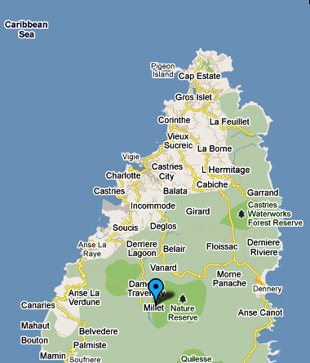The community of Millet is located in the interior forested area of St. Lucia and falls between the Grand Bois Forest and a major nature reserve which serves as a bird sanctuary. The area is also home to the John Compton Dam which provides water to the Northern section of the island or more than 60% of the population.

The elevation of Millet ranges from 738-1000Ft above sea level especially in Bird Sanctuary. The Community is about 17.7 Km from the City of Castries or about 21 minutes of driving.

Coordinates: 13.54.08.17N 60.59.04.47W

### Population of the Millet

1857 Persons / Household Population: 688

Males: 935 / Females: 922

### 

### Community map

### C:\Users\GLORY LOVE\AppData\Local\Microsoft\Windows\Temporary Internet Files\Content.Word\New Picture.bmp

## Direct observation

|  |  |
| --- | --- |
| ***Demographics*** | ***Health, Sanitation & Essential Services*** |
| * The community has a population of 1857 persons with a household population of 688 and an average family size of 2.8; * Gender breakdown: Males- 935 / Females- 922; * Males make up 50.8% of the population compared to 49.2% of women; * More than 50% of the population falls between the ages of 0-40 reflecting the community has a high percentage young and middle age persons; * An unemployment population of 2% predominantly among young persons; * 61% of households are headed by men; * Dwelling houses are predominantly made from wood (plywood) or concrete blocks, with wood accounting for 55% of the material used; | * The community is serviced by a new Health Center, Daycare Center and a Primary and Infant School, along with a Community Center in Tete-Chemin and another one in Durandeau; * There is also the presence of the Catholic, Seventh Day Adventist Church, the Jehovah Witnesses Kingdom Hall, Pentecostal and Baptise Church; * Police presence can be had from the Marigot Sub Police Station which is approximately 10 minutes driving distance away or Castries Police Station which is estimated to be 18 minutes away. * Medical and Fire Emergency Services are accessed from the Castries Fire Station; * The main national Hospital, the Victoria Hospital is about 15 minutes away from the community along with the National Wellness Center and the Tapion Private Hospital * Garbage collection system exist throughout the community however due to the rural and forested nature of the community, dumping of garbage takes place in backyards and the river. * Pipe borne water exist within the community and most persons access water from their homes, however the river is also utilized during water shortages and for agricultural purposes * 32% of houses are linked to septic tank/soak-away * A high percentage of home almost 68% still use Pit latrines (VIP); * Electricity is available throughout the community with most areas having the presence of electrical lamp except feeder roads or tracks which may not be properly lit * Landlines (telephone) are widely available in the community in 46% of homes; * mobile phones have become the predominant mode of communication with 75% of persons using it as the major form of communication; |
| ***Daily Activities*** | ***Visible Vulnerabilities and Capacities*** |
| * Adults are predominantly engaged in economic activities such as farming . * Women are generally involved in employment, caring of children and church related activities, Mothers’ and Fathers’ groups, Club 60 and the Millet Women’s Organisation; * Sports and other recreational activities are centered on the Playing field and Multi-purpose Court and are engaged in by most young men from the community; * Recreational activities of adults tend to stem around the playing of dominoes, attending “Country and Western” dances and watching television; * Adult males tend to socialise around the community rum shops, playing dominoes and engaging in the Solo group activities; * A large percentage of men are either employed in the farming or construction industry; * Catholic and Seventh Day Adventist are the major Christian denominations; * Public Transportation plays a pivotal role in the daily lives of residence and is the major form of transportation used by the community; * Younger persons are members of the Millet Drug Free Club or the Millet Karate Club; * A large percentage of children tend not to be associated with any youth organization and participate more in “liming” around the community especially on weekends; | ***Vulnerabilitie****s*   * Dark areas in some forested sections and alleys in the community; * The presence of the river running throughout major sections of the community along homes and the Durandeau community Center and bridges which connects Durandeau, Caico and Tete-Chemin; * Erosion along major parts of the community and in sections affected by landslides during Hurricane Tomas; * Large areas of bush which may tend to encourage rodents and a hiding place for a poisonous species of snake (Fer-de-lance); * The treacherous of the road leading up to Tete-Chemin; * The close proximity of utility poles predominantly electricity to homes and community shops; * The plethora of rum shops and illegal drug sale points in the community; * High percentage of wooden houses with poor roof structures * Poor drainage along most of the homes and a large percentage of homes are on hill sides; * High Presence of pesticide used due to the agricultural practices; * Storage of pesticides in a shed in the Durandeau community;   ***Capacities***   * Availability of small community shops; * Farmland and crops; * John Compton Dam * 2 Play Fields * River and springs * Pumice Mines * Human resources (teachers, police officers, mechanics, heavy equipment operators, farmers, construction workers, etc.) * Heavy equipment, minibuses * Four Wheel Drive Vans and trucks * Health Center, * Millet Primary and Infant Schools * 2 Seventh Day Adventist Churches * 1 Baptise and 1 Pentecostal Church * Roads and access routes along with bridges * Organised groups such as the, Youth and Sports Clubs, Church Youth Groups, Millet Women’s Organisations, Club 60, Millet Solo Group and the Millet Karate Club; * Durandeau and Tete-Chemin Community Centers * Day Care and Pre-School * Trees * Chain saws and operators * Multi-purpose Court |

## Focus group discussions

***A focus group discussion is a qualitative information-gathering tool whereby a group of selected individuals, guided by a facilitator, are invited to give their thoughts and views on a specific issue***.[4] To facilitate the process of interaction with key community stakeholders, the International Federation has developed a series of tools for participatory appraisals. These include, but are not limited to:

1. Historical profile;
2. Historical visualization;
3. Seasonal calendar;
4. Institutional and social network analysis;
5. Livelihoods and coping strategies analysis;
6. Mapping;
7. Transect walk;
8. Household/neighborhood vulnerability assessment;
9. Assessing the capacity of people’s organizations;
10. Venn diagram.

Not all tools are used every time, nor are these tools the only ones used to encourage community mobilization. More than the tools, the success of the VCA is measured by the mobilization it induces within the targeted community.

1. Historical profile;
2. Historical visualization;
3. Seasonal calendar;
4. Institutional and social network analysis;
5. Livelihoods and coping strategies analysis;
6. Mapping;
7. Transect walk;
8. Household/neighborhood vulnerability assessment;
9. Assessing the capacity of people’s organizations;
10. **Historical Calendar**

|  |  |
| --- | --- |
| **Year** | **Event** |
| 1934 | **Society Hall built, same site which now houses Durandeau Community Center** |
| 1934 | Infant and Primary School commences at Society Hall for the first time in the community |
| 1938 | First major landslide – forcing relocation of persons |
| 1970’s | First major disaster – vehicular accident killing a number if persons |
|  | Health Center Built in Durandeau |
| 1978 | Pipe-borne water and electricity available in community |
| 1980’s | Hurricane Allen impacts St. Lucia, destroying a large percentage of houses in the community |
|  | Health center built |
|  | Construction of John Compton Dam commences |
|  | Relocation of Tete-Chemin residents to Belair to accommodate construction of Dam commences |
| 1994 | **Major floods and landslide by tropical storm Debbie** |
| 2004 | **Health Center housed at Durandeau Community Center** |
| 2010 | New Health Center Opened in Millet |
|  | **Hurricane Tomas impacts community destroying houses, farms and causing major landslides** |
| 2011 | **CDRT team established** |
|  | **Saint Lucia Red Cross and PIRAC commences Shelter Project in Millet** |
|  |  |

### Some important historical points on the community lacked any date but are worth noting:

* To attend church Catholic Christians would walk to the village of Anse-La-Raye which was about 2hrs duration;
* The First Health Center was in the Community of La Croix and walking was the common way of getting there and took about 45mins;
* The original inhabitants of the community came from, Vieux-Fort, Choiseul, Soufriere, Dennery and Babonneau and came to work on the sugar and banana plantations;

### Historical visualization

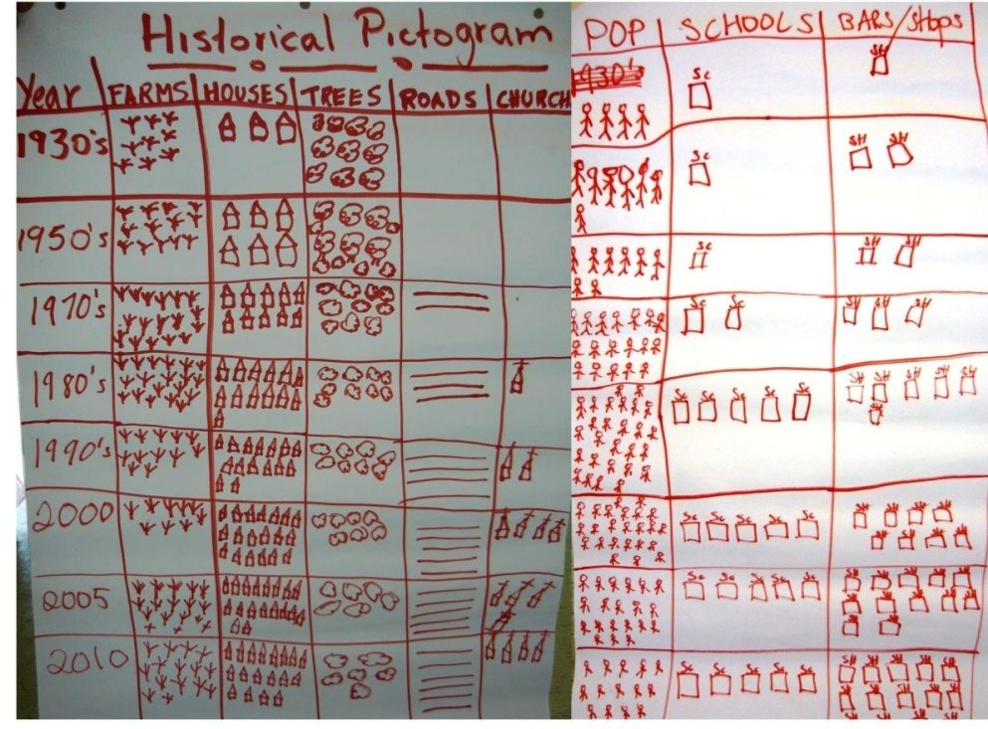

Millet has always been a unique community with its location being between the Grand Bois Forest and the Nature reserves which is home to a Bird Sanctuary and the John Compton Dam which provides water to more than 60% of the Saint Lucian Population.

Throughout the years the community has since grown in its population and farms and peacked in the 1970’s – 80’s. The 1980’s also brought with it a reduction in forest coverage particular due to a number of reasons:

Clearing for the construction of the John Compton Dam;

Relocation of persons in the Tete-Chemin area to other parts of the community and to the Sarrot community of Belair New Development;

Increase need for land to construct homes, schools and road networks;

During the period of 1985 – 1997 there was a reduction in the population of the community as a result of the relocation of 70 households or just over 200 persons to facilitate the construction of the Dam. The late 1990 and early 2000’s saw a drastic decline in banana farmers/farm workers and banana plantation as a result of the declining banana industry.

The community began to see a major shift in its appearance with a proliferation of bars/shops as other means of livelihood and with the growth in population the construction of a new community center, day care, pre-school and churches. The decline in forest coverage continued and the impact being very apparent with the frequent landslides and even more so during Hurricane Tomas resulting in the lost of farms and homes.

Between 2005 to present the agricultural sector has begun to flourish again with farms diversifying in more short term crops like vegetables and also increase production of ground provisions and pineapples. This has also brought with it an increase of vendors who purchase directly from farmers for resale at the market.

The population of the community continues to grow with the effect of reduced forest coverage and thus further increasing the vulnerability of the community to landslides, flooding and fires. Hurricane Tomas proved that a large percentage of the community has become very unstable especially in the Tete-Chemin, Caico and Venus areas and with increase rainfall further land slippage and loss of property, livelihood and lives can be easily realized.

### Seasonal calendar

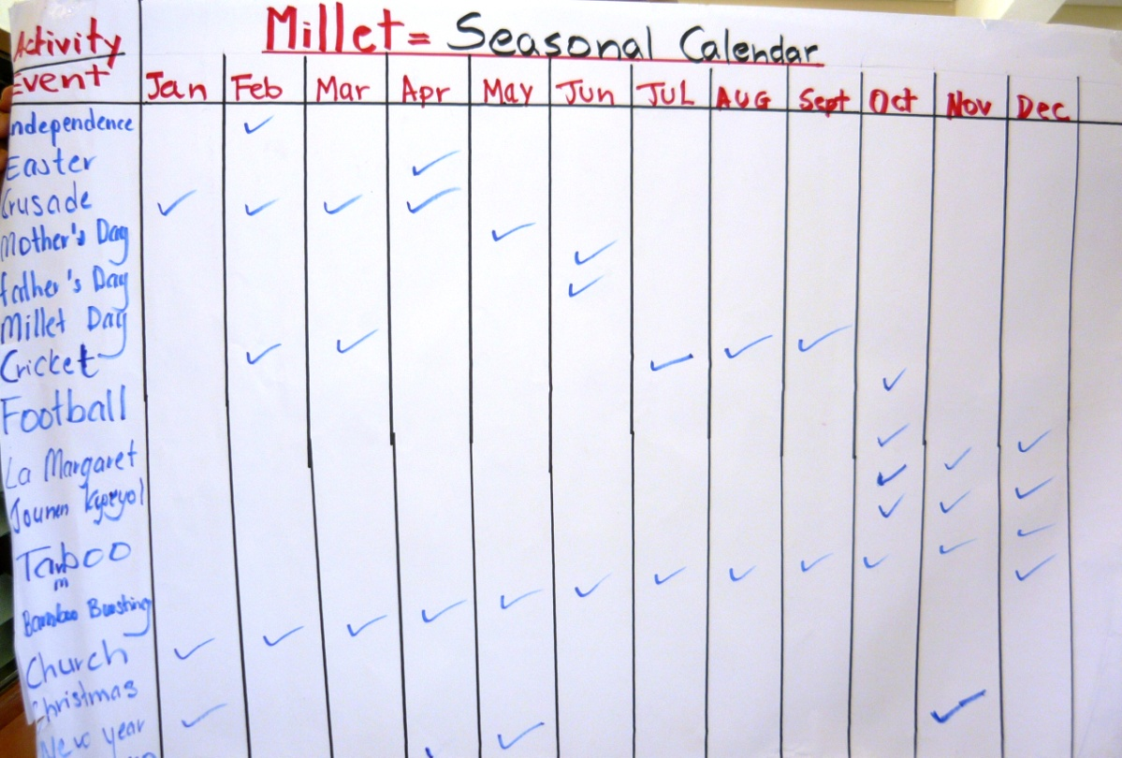

### Institutional and social network analysis

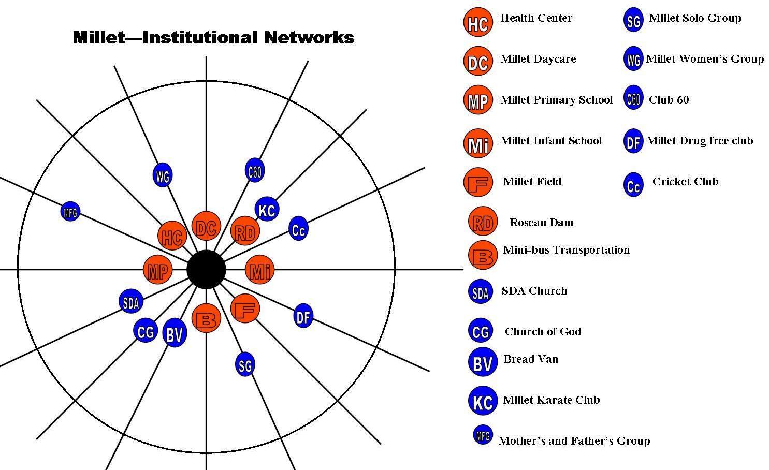

Millet has a plethora of organizations and social institutions focused on the development of their community. The major ones which tend to be at the center of community life are as follows:

* Health Center
* Day Care
* Primary and Infant School
* Playing Field
* John Compton Dam
* Mini-bus Transportation

Church activities on a daily basis tend to focus on their members, hower during Hurricane Tomas much support came from the Seventh Day Adventist Disaster Response structure.

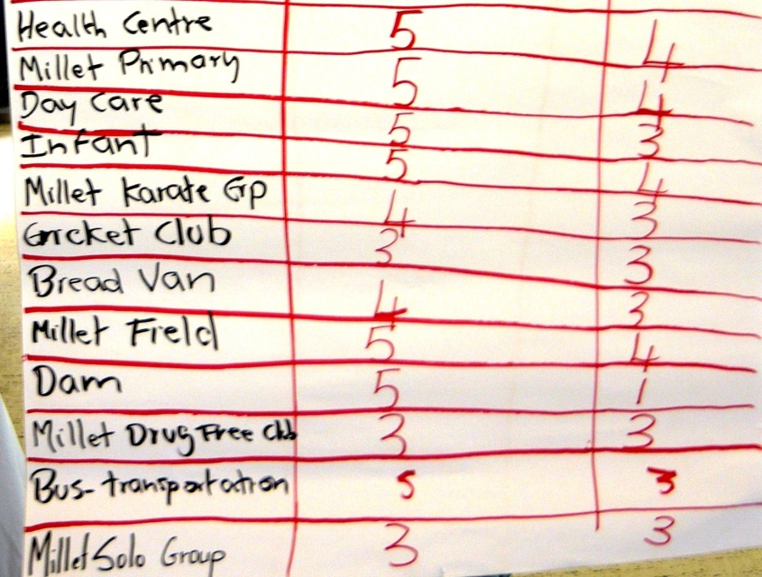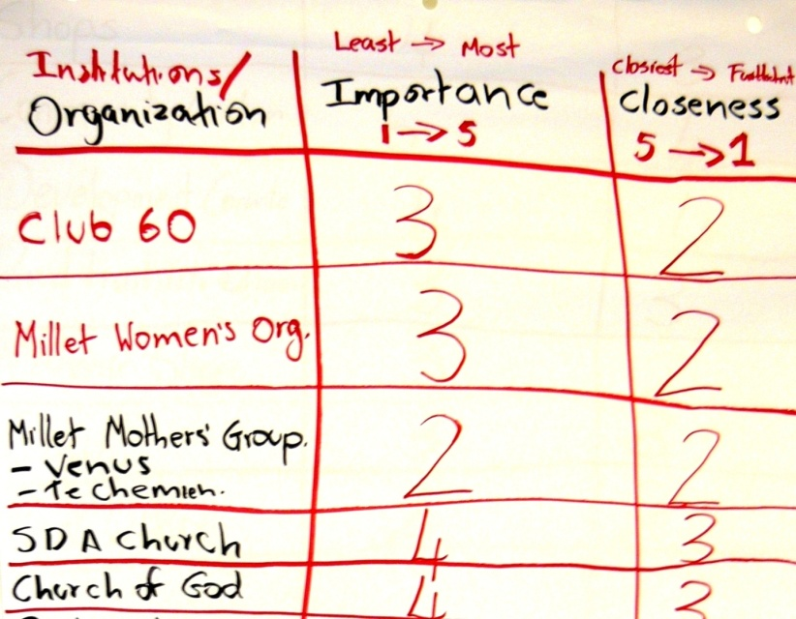

While other social organizations exist such as the Solo Group, Club 60, Mothers’ and Fathers’ Group and the other youth oriented organizations, their impact is not always apparent at the community level, except during activities associated to the group themselves.

### Livelihoods and coping strategies analysis

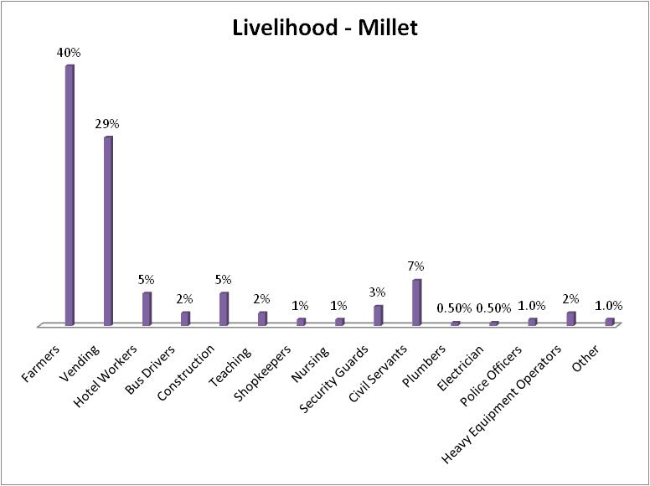Being in a major watershed area the environment provides the right type of conditions for farming and while other communities have felt the impact of a failing banana industry, 40% of persons in this area still rely of agriculture as their main source of livelihood.

Farming in the Millet area comprises predominantly of the following: Banana,

Vegetables,Ground provisions and livestock production.

The second largest source of income are from persons involved in the vending sector, though they don’t own any farmlands their produce are purchased from farmers and sold at the Castries market. Thus agricultural related activities are a source of livelihood for 69% of the community’s population. The government sector provides employment for 7% of the population contributing to the third largest area of employment. Persons engaged in this area are usually young women.

Common to Millet and other parts of the island, two other growing areas of employment are in the construction industry, employing more young men and the hotel industry which tend to have a larger percentage of young and middle age women.

Security guards along with heavy equipment operators and mini-bus drivers are the other major contributors, employing 2-3% of persons.

### Mapping

**Picture: Capacity Resource map**

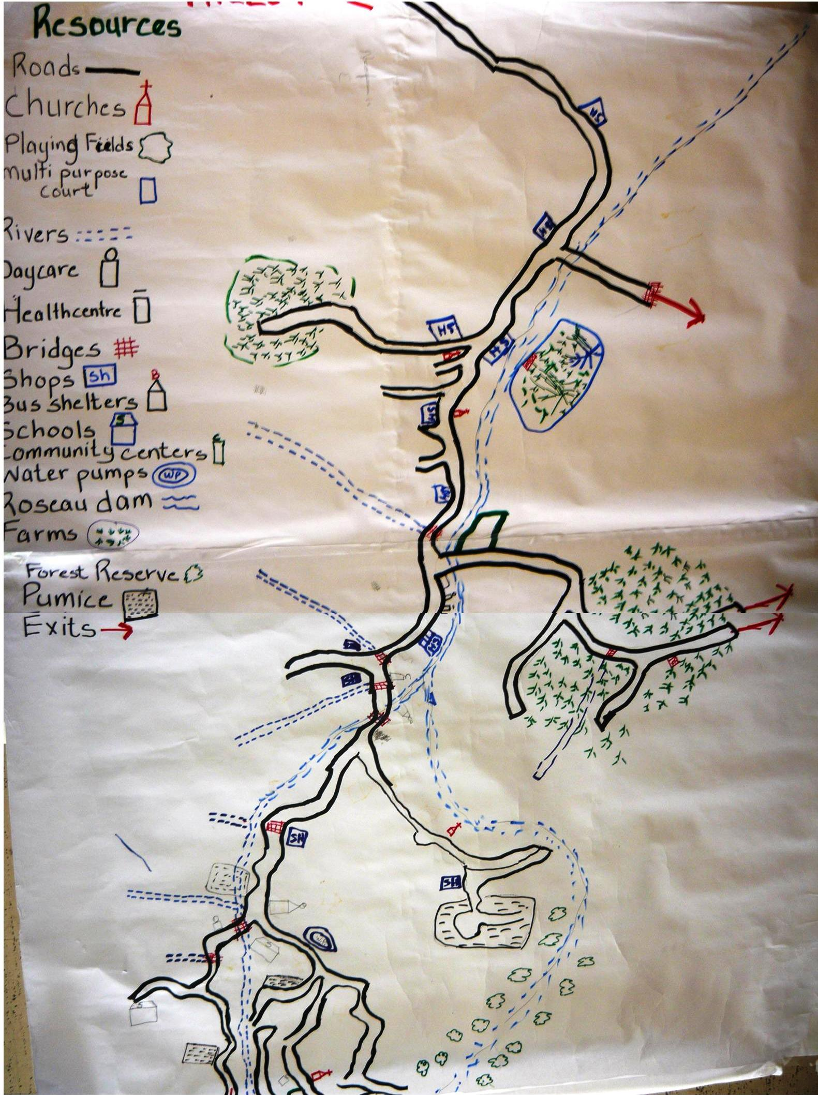

**Picture: Hazard map**

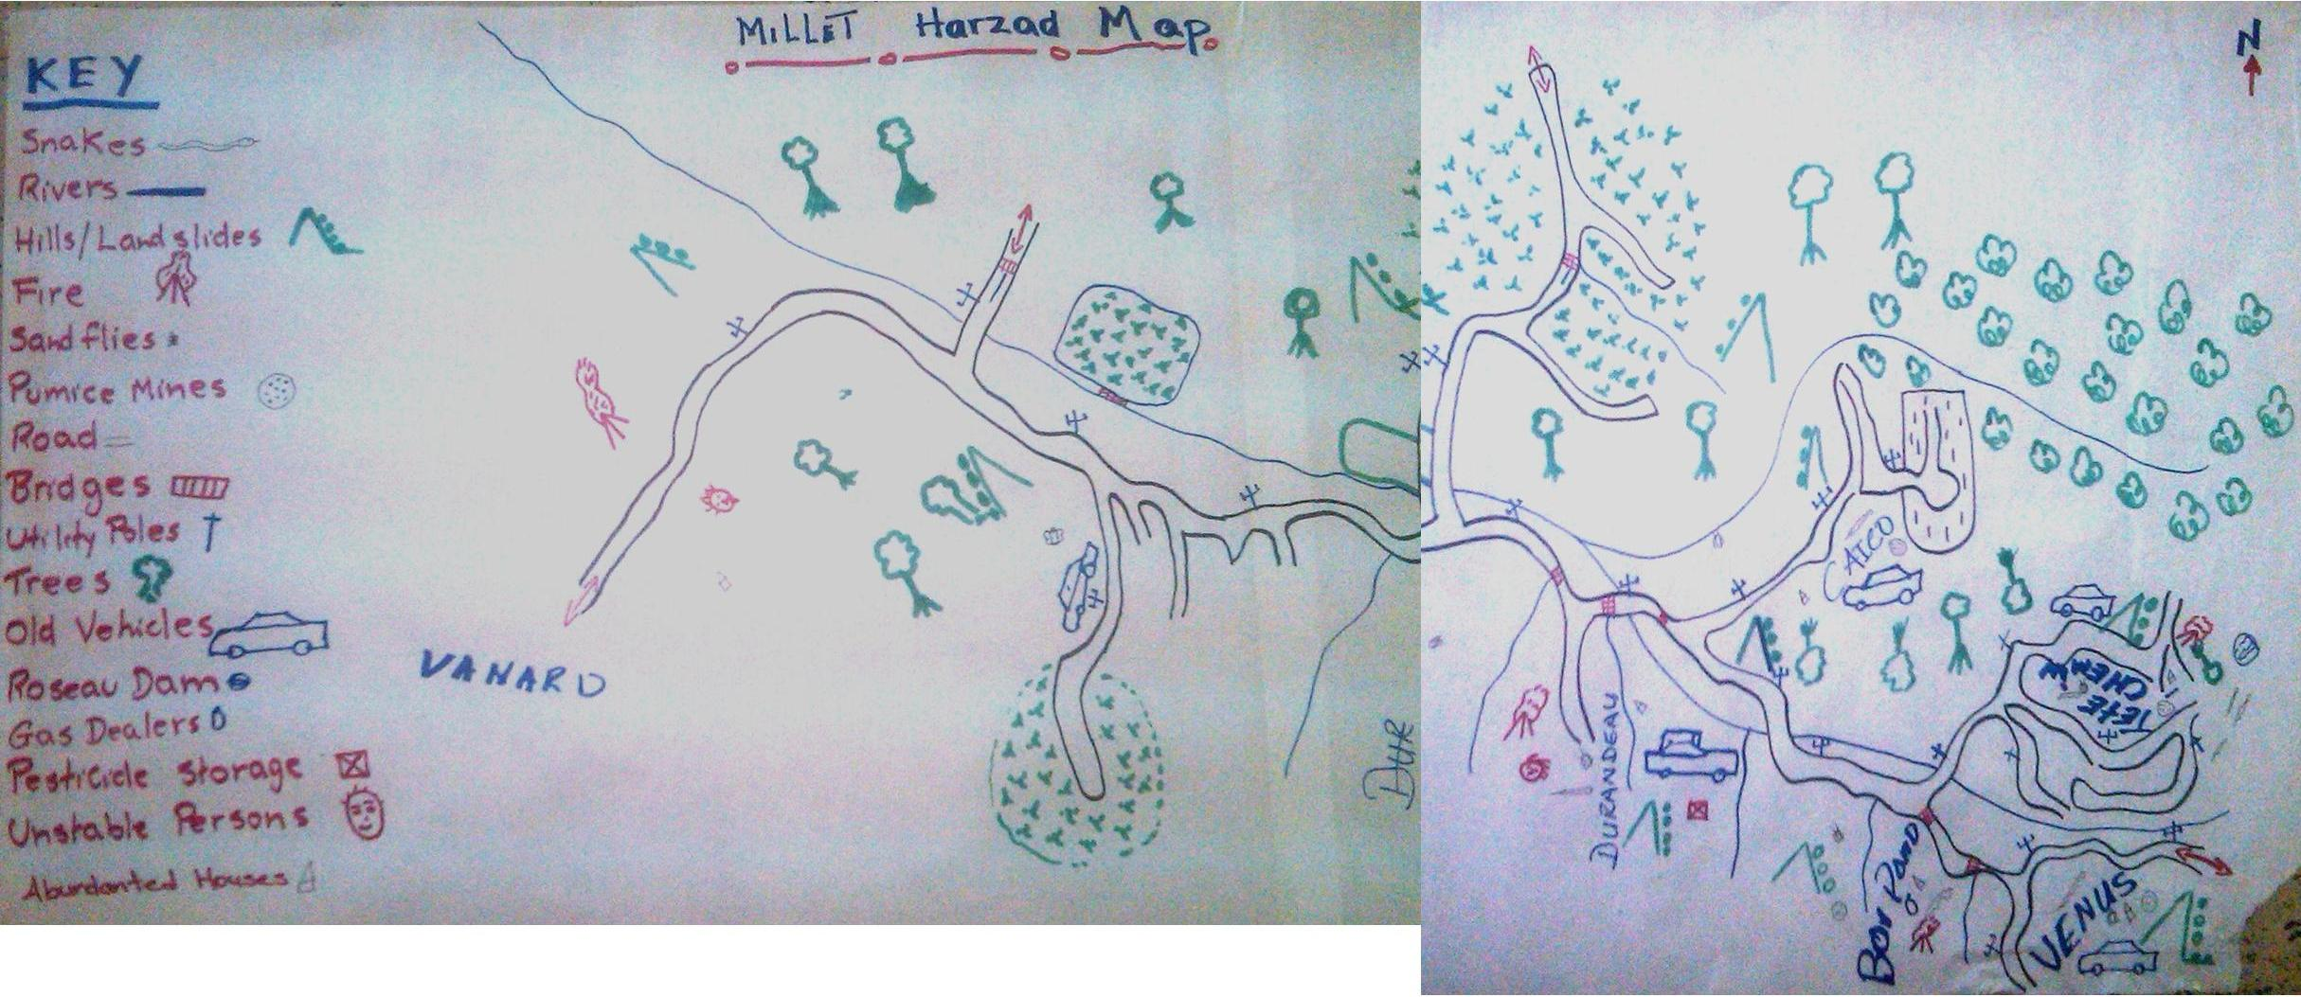

### Transect walk

|  |  |
| --- | --- |
| Morn D’Or to Vanard Gap | |
| Characteristics | This section of Millet is on the main road which is well paved. The left side of the road heading towards Millet contains banana and vegetable plots. The right side is the main residential areas with homes and small shops and is elevated compared to the flat section of left side. Closer to the Varnard cap, the left side becomes elevated with more homes and the right side is made of predominantly banana farms;  The main river has sections which runs through both sections of the community with Morn D’Or being the flattest in this area; |
| Livelihoods | Farmers, Minibus drivers, shop-keepers, butchers, civil servants, construction workers, hotel workers; |
| Hazards | Landslides, Flooding from the Millet river, over hanging trees, vehicular accidents, utility poles close to homes and businesses; |
| Resources | Farmlands and crops, river, transportation, skilled workers, shops, heavy equipment; |
| Soil Type | Predominantly clay loam soils with some parts having soil of a sandy loam nature due to the river; |
| Household Population | 160 / Family Size: 2.8 |

|  |  |
| --- | --- |
| Vanard Gap to Durandeau | |
| Characteristics | This section of Millet is on the main road which is well paved. The left side of the road has an exit to another community called Sarrot and is an alternative route into the community. This section is also residential with a very low portion having a large acreage of a private banana holding. Also on this side is the Health Center, Day care and playing field and the Durandeau Community Center which formerly housed the Health Center;  The right side of the community from the Vanard Gap has a high prevalence of concrete homes and a church. Heading down further into Durandeau, the land becomes flat with more residential homes and elevates again. Closer to the center of Durandeau are small shops, bars and more homes. |
| Livelihoods | Farmers, Minibus drivers, shop-keepers, butchers, civil servants, construction workers, hotel workers, Police Officers; |
| Hazards | Landslides, Flooding from the Millet river, over hanging trees, vehicular accidents, utility poles close to homes and businesses, snakes; |
| Resources | Farmlands and crops, river, paved roads and bridges, transportation, skilled workers, shops, heavy equipment; |
| Soil Type | Predominantly clay loam soils, rock, with some parts on the left hand side being of a sandy nature |
| Household Population | 102 / Family Size: 2.8 |

|  |  |
| --- | --- |
| Tete-Chemin Bridge to Millet Bird Sanctuary | |
| Characteristics | This is a very elevated section of the community which a large percentage of the area being forested and have some level of farming. The left side of the road starts out low with the river running through this section. The right side is very much elevated as the community continues and the highest point in Millet ends in the Bird Sanctuary almost 1000FT above sea level;  This is the most forested section of Millet and second most populated; |
| Livelihoods | Farmers, Minibus drivers, shop-keepers, butchers, civil servants, construction workers, hotel workers; |
| Hazards | Landslides, Flooding from the Millet river, over hanging trees, vehicular accidents, utility poles close to homes and small shops, snakes |
| Resources | Community Center, Schools, Day Care, Farmlands and crops, river, transportation, skilled workers, shops, heavy equipment, Forest trail, Post Office; |
| Soil Type | Predominantly clay loam soil, rock and sandy at the lower left section; |
| Household Population | 185 / Family Size: 2.8 |

|  |  |
| --- | --- |
| Caico Bridge to Caico | |
| Characteristics | This is the smallest residential section of Millet and starts out very low and becoming elevated especially in the farming sections. The left side of the community is predominantly residential with a church and a few small shops. The river separates the community from Durandeau and the bridge facilitates access to and from Caico.  The right-hand side is very much elevated and is made up of residential and farming lots. The highest section of the community is positioned on a sort of peninsular with the river on the left hand side. The lower valley areas are used for farming both livestock and crop production. The area also has the largest, pineapple and ground provision farms in Millet; |
| Livelihoods | Farmers, Minibus drivers, shop-keepers, butchers, civil servants, construction workers, hotel workers; |
| Hazards | Landslides, Flooding from the Millet river, over hanging trees, vehicular accidents, utility poles close to homes small shops, snakes, earthquakes; |
| Resources | Farmlands and crops, river, transportation, skilled workers, shops, heavy equipment; |
| Soil Type | Predominantly clay and sandy loam |
| Household Population | 81 / Family Size: 2.8 |

### Household/neighborhood vulnerability assessment

Population: 1857 Household type: Wood-55% / Concrete – 45%

Males: 935 / Females: 922 Poverty Index: Poorest – Lower Class

Unemployment: 2% Household Population: 688

Family Size Average: 2.8/persons

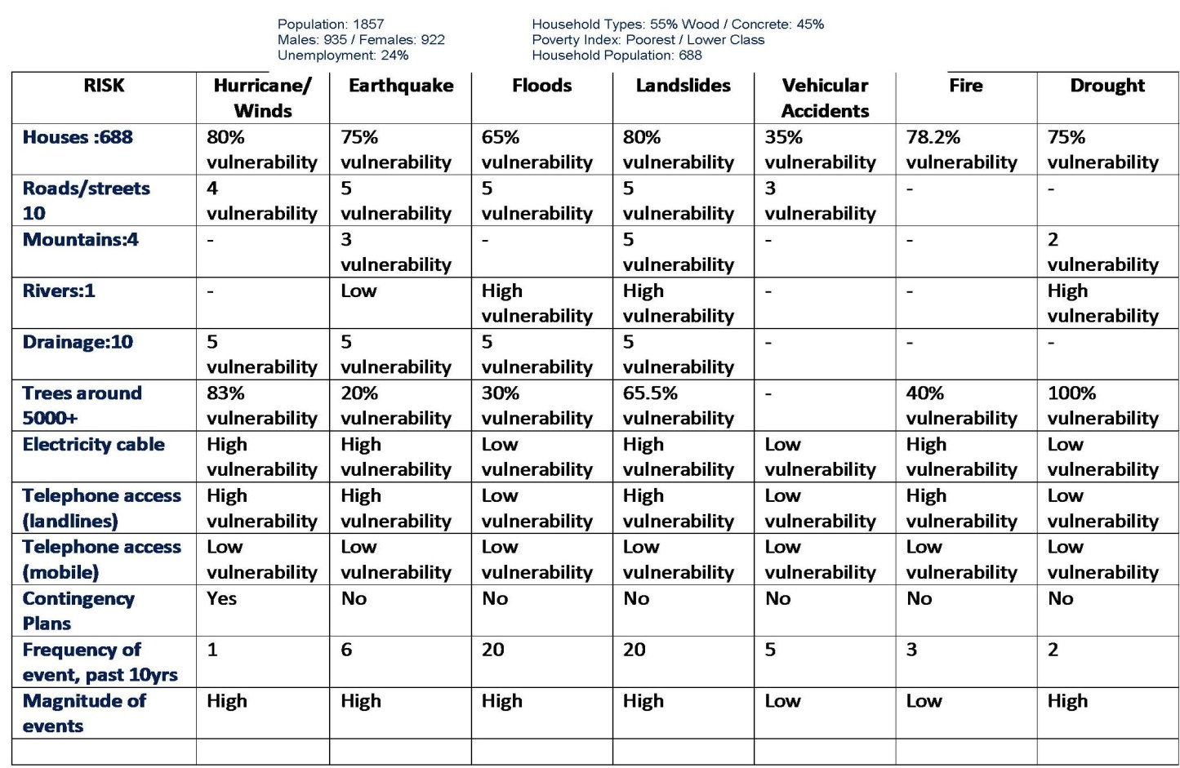

More than 50% of the homes in the Millet area are made of plywood and with very poor roof structures and are not built to withstand hurricane force winds. The results have been proven in the pass and very recently with Hurricane Tomas, which further exposed the vulnerability of the various homes in Millet especially those in the elevated sections of the community. The assessment revealed that out of the 688 homes, 80% of them are vulnerable to hurricane wind damage.

The other major risk which homes and the rest of the community are exposed to, is that of Landslides and Flooding. In the low areas 65% of homes and small shops are vulnerable due to the presence of a river that runs throughout the entire community. Sections of the community are connected via bridges which are very vulnerable to flood waters.

Most of Millet is actually elevated areas such as Venus, Caico, Tete-Chemin and parts of Durandeau in particular. These sections are also the major farming areas and as a result 80% of the homes are exposed to landslides. Land slippage has become a common factor in the community, not only exposing homes to the risk but also farmlands and crops a source of livelihood for more than 69% of the population.

Being a forested community exposes the area to the impact of drought while it may not be from water shortage but from possible bush fires an indirect effect of Droughts. The issue of fire brings with it the concern on the isolation of the community from fire and emergency personnel as 78.2% of the homes are at risk.

# Part 2: Risk assessment in Name of Village

The VCA process made it possible for the St. Lucia Red Cross Society (SLURC) to get toknow Name of Village, while allowing the community members to share their knowledge, their fears and their ideas. At the same time, the project has offered a unique opportunity to go from theory to practice.

The SLURC – in collaboration with partner agencies and local community stakeholders – has used the VCA method to identify and solve problems within their capability. In particular, as the following pages will show, the implementation of the VCA tools improves understanding of:

* the nature and level of risks that vulnerable people face;
* where these risks come from;
* who will be the worst affected;
* what is available at all levels to reduce the risks; and
* what initiatives can be undertaken to strengthen the impact of programs to raise the capacity of people at risk.

### Methodology for a Risk assessment

The following five-step approach was used with the Name of Village community members:

1. The first step meant identifying for each hazard the **Potential Risks to the community**; the areas of vulnerability and capacity that exists within the community.
2. The second step required identifying for each Hazard **Actions that could be undertaken** to transform vulnerabilities identified into capacities.
3. The third step consisted in differentiating the types of measures, whether they related to prevention, mitigation or preparation for response.
4. The fourth step involves a CIA Analysis, in which participants considered each and every action to transform vulnerability into a capacity and decide whether such changes were realistic.
5. The fifth and final step involved identifying a Plan of Action that could be implemented by the community. While a number of actions were identified, this final step identified realistic actions. It should be noted that the information gathered and the specific actions identified below while not reflected in the final plan of action are still relevant and needed and could be utilized by other agencies.

The results of these five steps are presented hereafter (points 1 through 5 below).

## Identifying hazards and their potential impact on the community

|  |  |  |  |
| --- | --- | --- | --- |
| Hazard | Potential Risk | Vulnerability | Capacity |
| **River/Flooding** | * Loss of life and Property * Loss of livelihood * Damage to property * Damage to access routes * Damage to road/bridges | * Lower sections of the communities with farms and homes * Small shops close to the river and bridges * Durandeau Community Center * Playing Field * Bridges throughout the entire community | This community has a wealth of resources both physical and human and they same resources are usually called upon to assist in the development or needs of the community.  Below is a list of some of the resources available to the community in ensuring there development towards a safer and more resilient Millet  ***Human Resources:***   * *Heavy equipment operators* * *Minibus drivers* * *Extension Officers* * *Farmers* * *Police Officers* * *Nurses* * *Firemen* * *Educators* * *Construction workers* * *Member of Parliament* * *Mechanics* * *Disaster Preparedness workers*   ***Physical Resources***   * *Heavy equipment* * *Four wheel vehicles* * *Trucks* * *Minibuses* * *Crops and Farm lands* * *Lumber* * Health Center * 2 Community Centers * School and Church Buildings * Pumice Mines * Chainsaws * Construction equipment * Forest trail * Bird Sanctuary * John Compton Dam |
|  |  |  |
| **Landslides/Steep slopes** | * Loss of farm lands and crops * Loss of land * Loss of property * Damage to utility poles * Damage to homes and businesses * Loss of life * Loss of livelihood * Damage to access routes/roads and bridges * Damage to water mains * Difficulties in sourcing lands for relocation | * Homes in all sections of Millet, above or just below sloping areas * Infant School * Farmlands and crops throughout Millet especially in Caico and Tete-Chemin and Venus * Millet road from Durandeau heading into Caico, Tete-Chemin and Venus |
|  |  |  |
| **Millet road** | * Vehicular accidents * Loss of life and Property * Loss of livelihood * Damage to property | * Workers * Passengers * Staff and Students of the various schools * Pedestrians * Motorist * Homes and small shops along the road |
|  |  |  |
| **Drought** | * Loss of homes and businesses * Loss of productive days, school/work * Damage to homes and property * Loss of livelihood * Loss of Wild Life * Bush fires * Loss of life | * Farm lands in the community * Millet river * John Compton Dam * Crops * Homes close to trees especially in the interior of the community * Homes in Millet * Infant and Primary schools * Daycare and Pre School * Health Center |
|  |  |  |
| **Overhanging Trees** | * Damage to utility poles * Damage to homes and property | * Electricity and telephone poles along the Millet road and within the community * Some houses and shops along the road * Motorist and Pedestrians |
|  |  |  |
| **Fire** | * Loss of lives * Loss of productive days * Damage to property * Loss of property | * Homes and small shops in the community; * Residents |
|  |  |  |
| **John Compton Dam** | * Loss of farm lands and crops * Loss of property * Damage to utility poles * Damage to homes and businesses * Loss of life * Loss of livelihood * Damage to access routes/roads and bridges * Damage to water mains * Loss of Water Supply to the island | * Homes and small shops in the community; * Farmlands and crops in the Tete-chemin and Venus area * Homes and property at the lower end of the Dam * Roads and Bridges in Tete-Chemin, Venus and lower areas |
|  |  |  |
| **Earthquake** | * Damage Water and utilities mains * Loss of lives * Loss of Property * Fires and explosions * Damage to property * Loss of land holdings * Damage to access routes and bridges * Damage to Dam | * Bridges throughout the community * The Primary and Infant Schools * Day Care and Pre School * Tete-Chemin and Durandeau Community Center * Health Center * John Compton Dam * Homes particularly concrete ones * Churches in the community |
|  |  |  |
| **Poorly lit areas** | * Loss of life * Vehicular accidents * Damage to property * Loss of productive work/school days | * Road users * Residents * Along the Durandeau section headin up to Tete-Chemin and Caico * Homes in the upper sections of the community |
|  |  |  |
| **Hurricanes/Winds** | * Loss of life and Property * Loss of livelihood * Damage to property * Damage to community infrastructure | * Residents of Millet * Tete-Chemin and Durandeau Community Center * Infant and Primary Schools * Wooden houses especially in the Durandeau, Caico and Tete-Chemin area * Small wooden shops in the community |
|  |  |  |
| **Poisonous Snake** | * Loss of lives * Loss of productive days * Loss of head of household | * Farmers * Children * Elderly |

## Local capacity to respond to hazards

|  |  |  |
| --- | --- | --- |
| **Hazard** | **Vulnerability** | **Actions to transform vulnerabilities into capacities** |
| **River/Flooding** | * Lower sections of the communities with farms and homes * Small shops close to the river and bridges * Durandeau Community Center * Playing Field * Bridges throughout the entire community | * De-silting of river; * Construction of retaining walls along river bank * Planting of trees to stabilize river bank * Helping families to plan for emergencies * Clearing and construction of drains around homes |
|  |  |  |
| **Landslides/Steep slopes** | * Homes in all sections of Millet, above or just below sloping areas * Infant School * Farmlands and crops throughout Millet especially in Caico and Tete-Chemin and Venus * Millet road from Durandeau heading into Caico, Tete-Chemin and Venus | * Encourage farmers to practice better farming practices; * Planting of trees to stabilize slops; * Relocation of threaten homes; * Construction of drains to redirect water flow; |
|  |  |  |
| **Millet road** | * Workers * Passengers * Staff and Students of the various schools * Pedestrians * Motorist * Homes and small shops along the road | * Road safety education programme for the community and other road users * Installation of Road Safety Sign * Construction of a bus shelter |
|  |  |  |
| **Drought** | * Farm lands in the community * Millet river * John Compton Dam * Crops * Homes close to trees especially in the interior of the community * Homes in Millet * Infant and Primary schools * Daycare and Pre School * Health Center | * Promote water conservation techniques; * Encourage farmers to practice water conservation techniques; * Promote rain water harvesting and storage among residents and farmers; |
|  |  |  |
| **Overhanging Trees** | * Electricity and telephone poles along the Millet road and within the community * Some houses and shops along the road * Motorist and Pedestrians | * Trimming of trees around homes and businesses * Alerting relevant utility companies about trimming of trees |
|  |  |  |
| **Fire** | * Homes and small shops in the community; * Residents | * Fire prevention education * Establish bucket brigade for community * Encourage small business and shops to install fire extinguishers * Encourage homes to install smoke detectors * Conduct fire drills in community and other institutions |
|  |  |  |
| **John Compton Dam** | * Homes and small shops in the community; * Farmlands and crops in the Tete-chemin and Venus area * Homes and property at the lower end of the Dam * Roads and Bridges in Tete-Chemin, Venus and lower areas | * Promote the development of a contingency plan * Practice evacuation drills |
|  |  |  |
| **Earthquake** | * Bridges throughout the community * The Primary and Infant Schools * Day Care and Pre School * Tete-Chemin and Durandeau Community Center * Health Center * John Compton Dam * Homes particularly concrete ones * Churches in the community | * Encourage the development of Family emergency plans; * Promote earthquake impact reduction; techniques in the community; * Community Education sessions for residents * Develop earthquake contingency plan for Millet; * Practice drills at the community level; |
|  |  |  |
| **Poorly lit areas** | * Road users * Residents * Along the Durandeau section heading up to Tete-Chemin and Caico * Homes in the upper sections of the community | * Install more streets light the entire Millet road, especially in the Durandeau and Tete-Chemin section; * Regular clearing or bushy areas and around bends long the road; |
|  |  |  |
| **Hurricanes/Winds** | * Residents of Millet * Tete-Chemin and Durandeau Community Center * Infant and Primary Schools * Wooden houses especially in the Durandeau, Caico and Tete-Chemin area * Small wooden shops in the community | * Develop Family Emergency Plans with community members * Encourage persons to retrofit their roofs * Conduct roof inspection and provide assistance to elderly persons in retrofitting roofs * Conduct drills in the community to promote preparedness |
|  |  |  |
| **Poisonous Snakes** | * Farmers * Children * Elderly | * Community education on snakes and safety * Community education of treating snake bites |

## Type of measures to mitigate disasters

The third step consisted in differentiating the types of measures, along three categories:

* Prevention actions: action which tries to reduce to probability of a disaster in the community;
* Mitigation actions: action that attempts to protect, strengthen, rehabilitate or reconstruct;
* Preparation actions: action that aims to strengthen the capacity of the community of Bamboo to respond in an effective and efficient manner

Identifying prevention, preparation and mitigation activities

|  |  |  |  |
| --- | --- | --- | --- |
| **Actions to transform vulnerabilities into capacities** | | | |
| **Hazard** | **Prevention** | **Preparedness** | **Mitigation** |
| **River/Flooding** |  | * Helping families plan for emergencies | * De-silting of river; * Construction of retaining walls along river bank * Planting of trees to stabilize river bank * Clearing and construction of drains around homes |
|  |  |  |  |
| **Landslides**  **/Steep slopes** | * Relocation of threaten homes; |  | * Construction of drains to redirect water flow; * Encourage farmers to practice better farming practices; * Planting of trees to stabilize slops; |
|  |  |  |  |
| **Millet road** |  | * Road safety education programme for the community and other road user | * Installation of Road Safety Signs * Construction of a bus shelter |
|  |  |  |  |
| **Drought** |  | * Promote rain water harvesting and storage among residents and farmers; * Promote water conservation techniques in the homes; * Encourage farmers to practice water conservation techniques; |  |
|  |  |  |  |
| **Overhanging Trees** |  |  | * Trimming of trees around homes and businesses; * Alerting relevant utility companies about trimming of trees |
|  |  |  |  |
| **Fire** |  | * Conduct fire drills in community and other institutions; * Establish bucket brigade for community; | * Encourage small business and shops to install fire extinguishers; * Encourage homes to install smoke detectors; * Fire Safety and prevention education |
|  |  |  |  |
| **John Compton Dam** |  | * Promote the development of a contingency plan; * Practice evacuation drills; |  |
|  |  |  |  |
| **Earthquake** |  | * Develop earthquake contingency plan for Millet; * Practice drills at the community level; * Community Education sessions for residents; * Encourage the development of Family emergency plans; | * Promote earthquake impact reduction techniques in the community; |
|  |  |  |  |
| **Poorly lit areas** | * Install more streets lights on the entire Millet road, especially in the Durandeau and Tete-Chemin section; |  | * Regular clearing or bushy areas and around bends long the road; |
|  |  |  |  |
| **Hurricanes/Winds** |  | * Conduct drills in the community to promote preparedness; | * Develop Family Emergency Plans with community members; * Encourage persons to retrofit their roofs; * Conduct roof inspection and provide assistance to elderly persons in retrofitting roofs; |
|  |  |  |  |
| **Poisonous Snake** |  | * Community education of treating snake bites; | * Community education on snakes and safety; |

## Ability to act on hazards (CIA/T analysis)

The fourth step involves a CIA Analysis[5], in which participants considered each and every action to transform vulnerability into a capacity and decide whether such changes were realistic. Each problematic situation had to be categorized according to the three possible options:

* the situation can be **changed** with the participation of the people at risk;
* the situation cannot be changed directly, but could be **influenced** by the people at risk so that third parties can offer a solution to the identified need; or
* the situation cannot be changed or influenced and the community needs to **accept** the threat as it is.

|  |  |  |  |  |  |  |
| --- | --- | --- | --- | --- | --- | --- |
| **Hazard** | **CIA/T** | **Prevention** | **CIA/T** | **Preparedness** | CIA/T | **Mitigation** |
| **River/Flooding** |  |  | **C** | * Helping families to plan for emergencies | I | * De-silting of river; |
|  |  |  |  | I | * Construction of retaining walls along river bank |
|  |  |  |  | C | * Planting of trees to stabilize river bank |
|  |  |  |  | C  C | * Clearing and construction of drains around homes |
|  |  |  |  |  |  |  |
| **Landslides**  **/Steep slopes** | **A/T** | * Relocation of threaten homes; |  |  | **I** | * Construction of drains to redirect water flow; |
|  |  |  |  | **I** | * Encourage farmers to practice better farming practices; |
|  |  |  |  | **C** | * Planting of trees to stabilize slops; |
|  |  |  |  |  |  |  |
| **Millet road** |  |  | C | * Road safety education programme; | I | * Installation of Road Safety Sign |
|  |  |  |  |  | * Construction of a bus shelter |
|  |  |  |  |  |  |  |
| **Drought** |  |  |  | * Promote rain water harvesting and storage among residents and farmers; |  |  |
|  |  |  | C | * Promote water conservation techniques in the homes; |  |  |
|  |  | C | * Encourage farmers to practice water conservation techniques; |  |  |
|  |  |  |  |  |  |  |
| **Overhanging Trees** |  |  |  |  | **C** | * Trimming of trees around homes and businesses; |
|  |  |  |  | **I** | * Alerting relevant utility companies about trimming of trees |
|  |  |  |  |  |  |  |
| **Fire** |  |  | **C** | * Conduct fire drills in community and other institutions; | **C** | * Encourage small business and shops to install fire extinguishers; |
|  |  | **I** | * Establish bucket brigade for community; | **C** | * Encourage homes to install smoke detectors; |
|  |  |  |  | **I** | * Fire Safety and prevention education |
|  |  |  |  |  |  |  |
| **John Compton Dam** |  |  | **I** | * Promote the development of a contingency plan; |  |  |
|  |  | **C** | * Practice evacuation drills; |  |  |
|  |  |  |  |  |  |  |
| **Earthquake** |  |  | **I** | * Develop earthquake contingency plan for Millet; | **C** | * Promote earthquake impact reduction techniques in the community; |
|  |  | **C** | * Practice drills at the community level; |  |  |
|  |  | **C** | * Community Education sessions for residents; |  |  |
|  |  | **C** | * Encourage the development of Family emergency plans; |  |  |
|  |  |  |  |  |  |  |
| **Poorly lit areas** | **I** | * Install more streets light on the entire Millet road, especially in the Durandeau and Tete-Chemin section; |  |  | **C** | * Regular clearing or bushy areas and around bends long the road; |
|  |  |  |  |  |  |  |
| **Hurricanes**  **/Winds** |  |  | **C** | * Conduct drills in the community to promote preparedness; | **C** | * Develop Family Emergency Plans with community members; |
|  |  |  |  | **C** | * Encourage persons to retrofit their roofs; |
|  |  |  |  | **C** | * Conduct roof inspection and provide assistance to elderly persons in retrofitting roofs; |
|  |  |  |  |  |  |  |
| **Poisonous Snake** |  |  | **I** | * Community education of treating snake bites; | **I** | * Community education on snakes and safety; |

1. **Plan of Action**

**Plan of Action:**

|  |  |  |  |  |  |
| --- | --- | --- | --- | --- | --- |
| **Concept** | **Activities** | **Time Frame** | **Indicators**  **Achievement** | **Assumptions** | **Remarks** |
| CDRT Executive | * Selection/election of CDRT leadership | June 2011 | CDRT executive elected | Members are willing to serve |  |
| Emergency Plans | * Assist Families in developing emergency plans | May 2011 | 200 families have emergency plans | Families will be willing to participate in developing plans; |  |
| Disaster Plans | * Development of a Disaster Plan for Bexon | July 2011 | Disaster Plan for Millet Developed | Assistance from the Red Cross and NEMO is forthcoming; |  |
| Flooding/  River | * Planting of trees along the river bank | July 2011 | 250 trees planted throughout the community and along the river banks | Trees will be sourced from the Ministry of agriculture at no cost; |  |
| Disaster Simulation | * Disaster Simulation exercise | June 2011 | 1 disaster simulation activity conducted | Participation from CDRT members and community is forthcoming |  |
| Hurricane Preparedness Meeting | * Hurricane Preparedness Meetings with community members | July 2011 | At least 2 hurricane preparedness meetings conducted with community members |  |  |
| Overhanging Trees | * Community members will form groups to clear bush and cut trees * Informing relevant authorities about hazardous trees | July- August 2011 | Bush cleared and relevant authorities informed of dangerous trees | Permission is given by owners to cut trees,  Relevant authorities pay attention to the concern of team members; |  |
| Fire Safety | * Community education Programme on Home and Fire Safety; * Fire/Bucket Brigade training for Community | October 2011 | At least 2 Fires safety sessions conducted with community members  20 community members trained as a fire/bucket brigade team | Community members are willing to attend education sessions  CDRT members are willing to be trained as a bucket brigade |  |

# Conclusion: The next steps

The Millet CDRT has since been established after the production of this report. The team members have undergone their CDRT training and have been engaged in promoting the developing of emergency family plans with over 300 households.

The team has also undergone training on managing an EOC and participated in a desktop exercise to enhance their skills which will later be tested during a national disaster simulation organized by the Saint Lucia Red Cross.

Currently the Millet CDRT is about to embark on a micro project aimed at reducing the impact of a hazard on the community and developing their action plan along with a disaster plan for the community.

The group hopes to step up it’s education campaign and further promote the positive role of the team as was apparent during the Hurricane Tomas Relief Operation with the Saint Lucia Red Cross. The group is also assisting the Saint Lucia Red Cross and PIRAC with the Shelter project as a number of beneficiaries will be from their community.

# Annex 1: List of participants in the Vulnerability and Capacity Assessment

Resource Personnel

|  |  |  |
| --- | --- | --- |
| # | Names | Addresses |
| 452-5582/286-4144 | Ms. Terencia Gaillard | Saint Lucia Red Cross – Director General |
| 452-5582/715-0521 | Mr. Hubert Pierre | Saint Lucia Red Cross- Project Manager |
| 452-5582/719-6824 | Mr. Bennet Charles | Saint Lucia Red Cross- Field Officer |
| 452-5582/ | Mrs. Marva Oculien | Saint Lucia Red Cross- Communications Officer |
| 452-0825 | Mr. Hilton Oculien | Saint Lucia Fire Service –Chief Fire Officer (retired) |



Focus group meetings – Dates & participants

Focus group meetings – Dates & participants

|  |  |  |  |  |
| --- | --- | --- | --- | --- |
| Dates | Names | CDRT  Member | Contact Info | Addresses |
| August 4th 2010  August 11th 2010  August 18th 2010  August 25th 2010  Sept 1st 2010  Sept 8th 2010  Sept 15th 2010  Sept 22nd 2010  Sept 29th 2010  Oct 21st 2010  January 12th 2011  January 26th 2011 | Aaron Donovan |  | 7153837/451-1491 | Millet/Tete-Chemin |
| Jules Wilson |  | 720-1331 | Millet/Tete-Chemin |
| Felicia Joseph |  | 721-4915 | Millet/Caico |
| Lucia Valcin |  | 718-4378 | Millet/Caico |
| Mathew James |  | 7126725 | Millet/Caico |
| Adela Belony |  | 717-0578 | Millet/Vanard |
| Charmaine Valty |  | 519-6499 | Millet |
| Martin St. Rose |  | 718-2356 | Millet |
| Lucita Alexis |  | 712-0775 | Millet |
| Claudette Hippolyte |  | 718-8676/451-1022 | Millet |
| Dona Ornivile |  | 520-7392 | Millet/Tete-Chemin |
| Janelle Isimbert |  | 722-7001 | Millet |
| Amia Jn. Baptiste |  | 713-8561 | Millet |
| Veronica Hippolyte |  | 451-1008 | Millet |
| Kester Charlemagne |  | 713-7686/724-3061 | Millet |
| Torry Charles |  |  | Millet |
| Marcella Hull |  | 716-2995/460-4757 | Millet |
| Jonas Regis |  | 487-5441 | Millet |
| Mickey Henry | 286-5541 | Millet |
| Veronique Regis | 713-4082 | Millet |
| Judy Regis | 716-8677 | Millet |
| Sabrina Rodgers | 719-8132/451-1155 | Millet |
| Hershelle Boisville | 714-0722 | Millet |
|  | Ullene Jn.Baptiste | 714-7159 | Millet |
|  | Ken Regis | 719-7116 | Millet |
|  | Lydia Hippolyte |  | Millet |
|  | Roxie T. Francis | 518-6426 |  |
|  | Samantha Auguste | 717-9474 |  |
|  | Tamika Williams |  |  |
|  | Tasha Valty |  |  |
|  |  |  |  |

1. Quoted from *VCA toolbox with reference sheets*, IFRC, Geneva, 2007, page 6.
2. Quote and definitions from *Vulnerability and capacity assessment, An International Federation Guide,* IFRC, Geneva, 1999, page 11-12.
3. Idem, page 12, emphasis added.
4. From *VCA toolbox with reference sheets*, IFRC, Geneva, 2007, page 66.
5. CIA: C = change, I = influence, A = accept, T = transform